A watershed-specific formula to predict salmon reproduction using functional flow metrics

Claire Kouba, Jason Wiener, Leland Scantlebury and Thomas Harter

June 2025

# Abstract

In many rural areas of arid and semi-arid regions, balancing agricultural and environmental water needs is a key challenge facing resource managers. This is complicated by the tendency for the water needs of cultivated crops to be better understood than those of aquatic ecosystems. This work aims to quantify hydrologic conditions that support persistence of key ecosystem species using a functional flows framework, not in the context of a prescribed flow regime, but in terms of which features of the hydrograph are empirically correlated with specific ecological outcomes. We use the coho (*Oncorhynchus kisutch*) and Chinook (*Oncorhynchus tshawytscha*) salmon runs in Scott Valley, a 2,109 km2 undammed rural watershed in northern California, USA, as a case study.

Taking advantage of a nearly two-decade ecological monitoring dataset and long-term stream gauge measurements, we first examined hydrological-ecological correlations, then implemented four different statistical modeling exercises. Of these, we selected LASSO regression to generate a final predictive model for each species. This model is referred to as a “hydrologic benefit” function and uses hydrologic metrics (Z-scored for better inter-metric comparison) to predict units of $log_{10}\left(outmigrant/spawner\right)$. In the LASSO regressions, to balance the explanatory power of the models with the risk of overfitting, we used k-fold cross-validation to find the lowest-error value of the tuning parameter lambda.

Correlation coefficients indicate that hydrologic factors and spawner abundance both exert influence on juvenile fish production. In low-test-error LASSO regression models of $log_{10}\left(outmigrant/spawner\right)$, hydrology could explain a greater degree of variance for Chinook than for coho (approximately 60% and 40%, respectively). The hydrologic metric with the highest coefficient is earlier river reconnection during parents’ spawning for coho, and lower wet season baseflow for Chinook (though this could change with additional years of data, especially for the smaller coho dataset). This suggests that conditions during their parents’ spawning or as eggs and hatchlings may exert a significant influence on the mortality rates of the hatching juveniles in this study area.

The simplicity of this approach for empirically identifying hydrologic metrics with high ecological importance for a threatened species may make it useful in other watersheds, where sufficient ecological data are available. The hydrologic benefit function is intended to set the stage for evaluating trade-offs and supporting water management decisions in human-altered novel ecosystems.

# Practitioner points

1. Correlation coefficients indicate that juvenile fish production is not dominantly controlled by hydrologic factors or by spawner abundance but is influenced by both.
2. In statistical models, hydrology could explain a greater degree of variance in relative Chinook reproduction than in coho (60% versus 40%), suggesting that Chinook outcomes may be more sensitive to hydrology than coho.
3. The most important single hydrologic metric was earlier river reconnection/preferred habitat access during parents’ spawning for coho, and lower wet season median baseflow for Chinook. This supports an interpretation that conditions during their parents’ spawning (potentially, more time to find better nesting habitat) or as eggs and hatchlings (potentially, lower average winter flowrates producing less burial or scour of eggs laid in the mainstem Scott River) may exert a significant influence on the mortality rates of the hatching juveniles in this study area.
4. Finally, in models of juvenile abundance based on hydrology and spawner abundance, spawner abundance was identified as one of the 3 most important predictors for Chinook but not for coho. The important hydrologic predictors identified in all 8 statistical modeling approaches are listed below in order of season and life stage.

* Full list for coho:
  + higher first dry season high flows,
  + earlier first fall reconnection,
  + longer first wet season,
  + higher first wet season average baseflow,
  + larger first fall flow increase,
  + smaller second fall flow increase,
  + slower first spring recession, and
  + faster second spring recession.
* Full list for Chinook:
  + higher top 10% of flows in the dry season,
  + earlier fall reconnection,
  + lower wet season baseflows,
  + longer wet season, and
  + slower maximum spring recession rate.

# 1 Introduction

## 1.1 Motivation and objectives

Reconciliation ecology posits that some human-impacted ecosystems should be considered irrevocably-altered, “novel” systems (Moyle 2014; Yarnell et al. 2015), with their own specific management concerns. To implement this philosophy, rather than working to restore novel ecosystems to pre-human conditions, a natural resource manager would actively manage biodiversity in human-altered landscapes as a co-equal goal with extracting and cultivating natural resources to provide for human material needs (e.g., Robertson and Swinton 2005; Arthington, Bernardo, and Ilhéu 2014; Acreman et al. 2014; Yarnell et al. 2020). Ideally this management would be based on an empirical or mechanistic understanding of two key links: firstly, how management actions affect availability and quality of water, and secondly, how those hydrologic changes affect human beneficial uses and ecological receptors (Rosenfeld 2017).

A large body of research has focused on general methods for quantifying connections between water management, flow, and ecological responses, as discussed below; however, in practice, such natural resource management is often local (Tarlock 1993). Accordingly, the authors of this study have posed research questions tailored to conserving two specific salmon species, the threatened coho salmon (*Oncorhynchus kisutch*) and the less-threatened Chinook salmon (*Onchorhynchus tshawytscha*), in a specific study area: the Scott River watershed in northern California, USA. In this undammed, rural watershed, water use is primarily managed by managing land use. Balancing the competing water needs of fish and farmers is a key challenge for local water managers (Siskiyou County 2021). Agricultural water needs are well-known and can be estimated and scheduled (Siskiyou Resource Conservation District 1994; Parry 2013; CDFW 2021), but, in spite of decades of investigation by local, state and federal actors (e.g., SRWC and Siskiyou RCD 2003; NMFS 2014; CDFW et al. 2015; CDFW 2021), the ecological water needs in this balancing act are not as well constrained.

One method for estimating ecological water needs, developed for the hydrologic setting of California,is the functional flows framework (Escobar-Arias and Pasternack 2010; Yarnell et al. 2015, 2020; Grantham et al. 2020; Stein et al. 2021). Functional flow metrics are used to quantify potential ecological services provided by river flow in terms of flowrate magnitude, timing, frequency, and duration in distinct seasons of a water year, where water year is here defined to begin on October 1 of the year preceding the calendar year of the same number (i.e., water year 2020 begins on October 1, 2019). These metrics can be calculated for any location with daily river data using noise-processing algorithms (Patterson et al. 2020; Yarnell 2025) **(MORE APPROPRIATE CITATION FOR FLASHY CALCULATOR?)**. While much functional flows work has been dedicated to “top down” approaches (Tharme 2003) that characterize a natural or altered flow regime in its entirety (e.g., Yarnell et al. 2020; Stein et al. 2021), in this study we propose to break apart the hydrograph and assess the relative importance of individual functional flow types. In addition to functional flows, we define several other hydrologic metrics for purposes of this study.

Here, we address the second (“flow-to-ecology”) link referenced above: we assess the potential to empirically identify and prioritize hydrologic features that support the ecological needs of specific species (coho and Chinook salmon) in a specific ecological region (the Scott River watershed). We focus on the questions: while we expect both biotic (e.g., number of spawners) and abiotic (e.g., hydrological) factors to influence fishery success (Ward et al. 2024), which ecological observations are most correlated with hydrology, and thus amenable to this predictive exercise? Is the predictive power of hydrology different for two different species? Can we identify and prioritize important hydrologic metrics and use them as benchmarks for evaluating the effects of different management actions on this aquatic ecosystem?

## 1.2 Utility of modeling ecological responses to flow

Juvenile outmigrant production is one of the most obvious indicators of the health of an anadromous fishery (Jager and Rose 2003), but is predicting outmigrant production (or any ecological response) using flow alone a worthwhile exercise, given the many interacting non-hydrologic factors (channel geomorphology, water quality, food resources, internal population dynamics) influencing a fishery (McMahon 1983; Bradford, Taylor, and Allan 1997; Escobar-Arias and Pasternack 2010; **WillisInstream2015?**)?

For some applications, it is not. Flow observations alone cannot represent site-specific hydraulics, which dictate the physical conditions for aquatic life; indeed, in different geomorphology, the same flow can produce very different hydraulic environments (Turner and Stewardson 2014). Flow observations also fail to capture other critical ecological drivers such as water quality, habitat quality, or food resources (e.g., **WillisInstream2015?**). Thus it is often fruitless to attempt to predict numerical fish recruitment based solely on hydrologic data; more complex approaches such as combining hydraulics with bioenergetic models (Bellido-Leiva, Lusardi, and Lund 2021), fish population and mortality (Jager and Rose 2003) or considering flow and water temperature (Nislow and Armstrong 2012) may produce better recruitment forecasts.

Nevertheless, in the absence of data such as site-specific flow-hydraulic relationships and dynamic population models, hydrologic-only approaches may be suitable for some types of natural resource planning (assuming the objective is more abstract than predicting numerical fish recruitment) (Nislow and Armstrong 2012; Turner and Stewardson 2014). Furthermore, they could enhance efforts to balance environmental and resource-extraction objectives (Jager and Smith 2008) while being based on relatively cheap and abundant hydrologic data. Among hydrologic-only methods, “top-down” approaches aim to support the flow needs of the entire ecosystem, often based on alteration of calculated hydrologic metrics from a pre-development flow regime (e.g., Poff et al. 2010; Arthington 2012; Yarnell et al. 2020), while “bottom-up” approaches aim to identify the individual flow features most critical to supporting a given objective (Tharme 2003). This study falls into the latter category.

## 1.3 Previous findings on California salmon flow requirements

Even within the geographic context of California, specific flows identified as being important to salmonids have varied by the study region, objective, and species under consideration. They include, in Central Valley rivers, winter minimum flows (Jager and Rose 2003) and early summer pulse flows and late winter overbank pulse flows (Jager 2014); and an indication that juvenile survival was highest in an intermediate flow range in the Sacramento River (Michel et al. 2021). In one adaptive management retrospective, two individual dam release pulse events improved habitat conditions for rearing juveniles during a critically dry year (Sellheim, Zeug, and Merz 2020). Optimal flow regimes are also different for different species-specific environmental objectives, and vary based on water year type (provide high spring flows in wet years) (Jager and Rose 2003). Conversely, in at least one study, flow differences had little effect on migration timing or growth of South Fork Eel River steelhead (Kelson and Carlson 2019).

This variability reflects that in different geomorphic and hydroclimate contexts, the habitat and ecological effects of identical flowrates is highly variable. This study aims to contribute to this body of work by proposing a simple method for identifying empirical relationships between flows and species focusing on the scale of a single watershed at which several other types of management choices are made.

## 1.4 History of flow-ecology relationships

A river’s flow regime is often referred to as a “master variable” controlling geomorphic, chemical, and other conditions in its aquatic ecosystems, and organisms that have evolved to persist in specific flow regimes are commonly negatively affected by flow alteration (Bunn and Arthington 2002; Poff et al. 2010). Consequently, in recent decades a diverse body of research has sought to identify and quantify ecological responses to changes in flow.

Bridging the gap between science and policy has been a persistent challenge and ongoing focus of work in this field. In many cases a key research motivation is to support decision-making in a variety of contexts, including dam operation, river restoration, and regulations of water extraction and land use (Richter et al. 2006; Han et al. 2015; Sinnathamby et al. 2018; Bradley et al. 2017; Brummer et al. 2016). But historical approaches based on relationship-finding are several steps removed from the policy-making process (Webb et al. 2018). For example, the Indicators of Hydrologic Alteration (Richter et al. 1996, 2017) and Ecological Limits of Hydrologic Alteration (ELOHA) (Poff et al. 2010; McManamay et al. 2013) approaches generate flow standards for particular rivers, and are a top-down method for determining the flow needs of the whole ecosystem, but cannot translate specific management decisions into hydrologic outcomes, or predict specific ecological outcomes of the described alteration (Richter et al. 2006; Cartwright et al. 2017). Additionally, identifying natural flow regimes may be less immediately relevant to water resource management than an approach which can quantify ecological responses to “designer” or functional flows (which can often be controlled or influenced by dam releases) (Arthington, Bernardo, and Ilhéu 2014; Webb et al. 2018), with the caveat that the designer flows approach may risk overlooking ecological flow needs that are not currently monitored (Bower et al. 2022).

An ideal framework for supporting decision-making would involve two key steps, firstly connecting land and water management actions to flow changes (“management-to-flow”), and secondly connecting flow changes to ecological responses (“flow-to-ecology”) (Peterson and Freeman 2016; DeWeber and Peterson 2020; Acero Triana, Chu, and Stein 2021). Both steps can involve complex models and substantial uncertainty, often representing an interdisciplinary challenge. Threshold values for “sufficient” flows would be ideal for a management context (Rosenfeld 2017), but can be difficult to identify and in some cases may not exist (Lueders and McManamay 2023). Finally, stakeholders in at least one study requested flow-ecology relationships based on empirical monitoring, rather than more easily-simulated proxies like flow changes or thermal exposure (DeWeber and Peterson 2020).

The present study is a longitudinal “bottom-up” analysis, using empirical data and a case study, to identify flows most critical to support two specific species, and thus address the “flow-to-ecology” link described above. We use empirical data to develop a predictive model of a biological response to measurable (and simulatable) changes in flow metrics. We refer to this model as a “hydrologic benefit” function (i.e., intending to quantify the ecological services provided by flow) for a single species. A forthcoming companion study will investigate the “management-to-flow” link, simulating flow changes from watershed management actions using an appropriate hydrologic model, as a basis for studying unavoidable water management tradeoffs within the watershed.

## 1.5 Historical assessments of Scott River flow-ecology relationships

Flow-ecology relationships have been investigated before in the Scott River Watershed, but the empirical “flow-to-ecology” link described above has not been quantified. Over the past three decades, several organizations and agencies have conducted extensive monitoring and published a series of reports and plans regarding the salmon fisheries in the Scott River watershed. In the 1990s, fall flows in the Scott River were reported to be too low in some years to allow for Chinook spawning in September-November (CRMP and SRWC 2000), but in the mid-2000s it was reported that low fall flows rarely affected the later (November-January) spawning runs of steelhead and coho salmon (SRWC and Siskiyou RCD 2005). More recently, fall flows have affected coho salmon as well as Chinook, as the late onset of winter storms has delayed coho spawning in some water years (e.g., CDFW 2015). In the mid-2000s, a local conservation organization identified the lack of suitable summer and winter rearing habitat as a probable limitation on Scott River coho smolt production (SRWC and Siskiyou RCD 2005). Several years later, in a NOAA Fisheries Coho Recovery Plan, NMFS identified the juvenile life stage as the most limited in the population (NMFS 2014).

# 2 Methods: Case study setting and species of concern

Exploring the empirical relationship between river hydrology and an ecological response requires both spatial and temporal overlap in a study area’s hydrologic and ecological monitoring data.

These requirements are met to some degree in Scott Valley, though as is typical, ecological data is the limiting factor. Hydrologic data is provided by daily river flow monitoring, which has been ongoing since the 1940s at the USGS stream gauge downstream of the town of Fort Jones (Station ID #11519500, or the Fort Jones Gauge or FJ Gauge; Figure 1). The flow at this gauge is correlated with flow in tributary streams (Foglia et al. 2013), and though a single monitoring location may not be able represent flow status in the full stream system at all times, it has been used in recent water planning documents as an indicator of overall hydrologic conditions (Siskiyou County 2021). Because most water use in Scott Valley occurs upgradient of this gauge, its measurements are used to inform water management decisions in the populated areas of the valley (see *Supplement* for more detail on Scott Valley management history, geography and climate).

## [1] FALSE

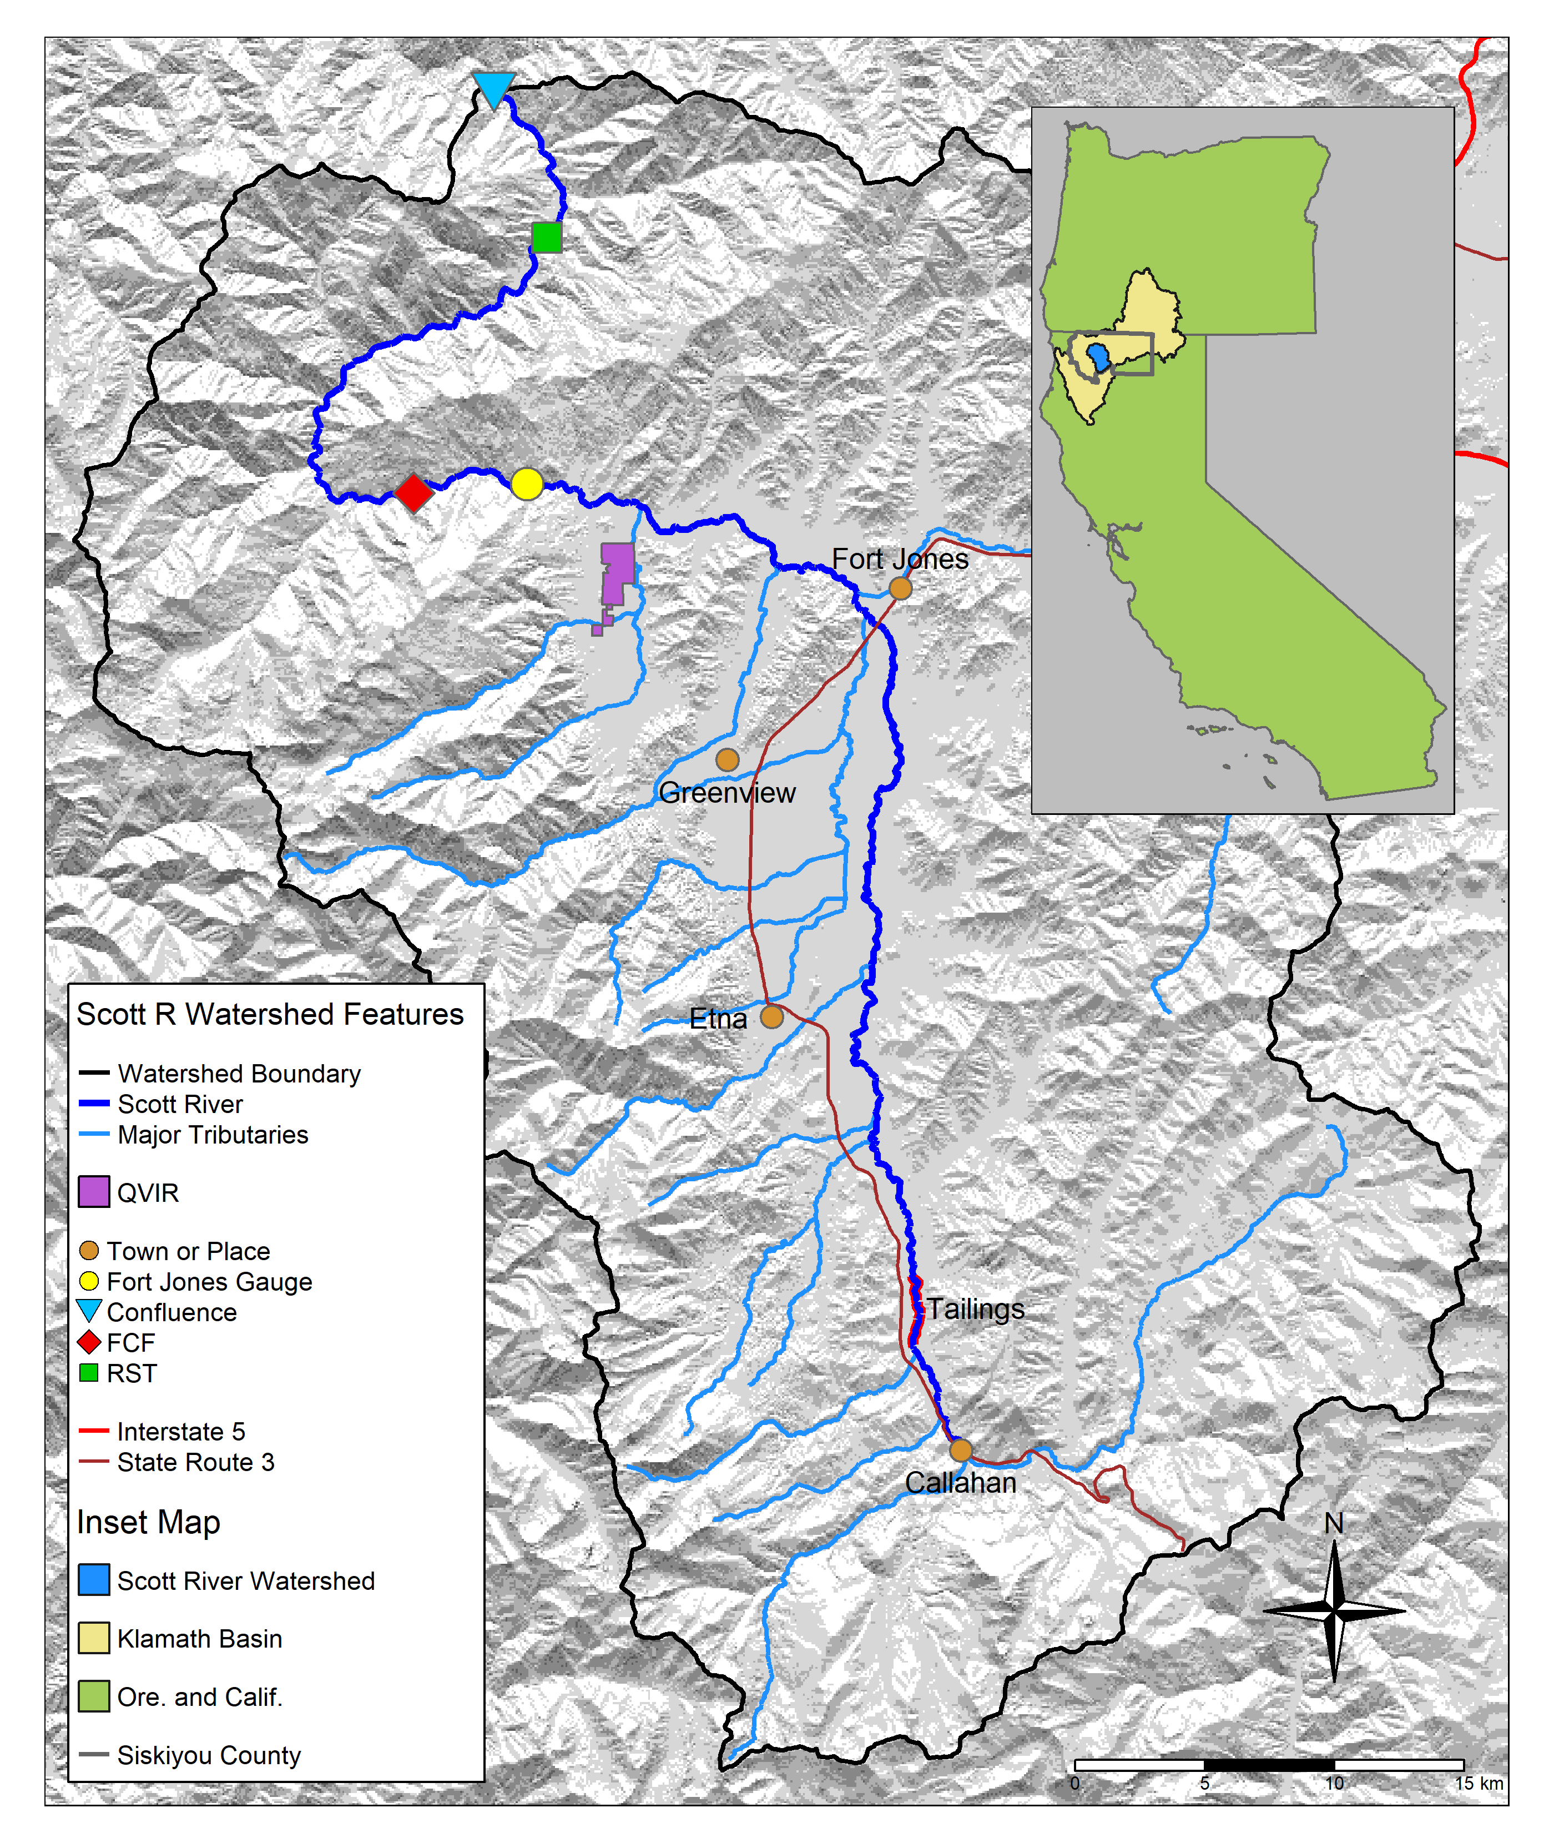

Figure 1: The Scott River watershed, with regional geographic context (see inset) and local features.

## 2.1 Species of concern: coho and Chinook salmon

This study intends to identify key hydrologic needs of two species, coho and Chinook salmon. To this end, we used several decades worth of hydrologic and ecological data collected in the Scott River watershed. Although both species need fall flows to migrate from the ocean to natal spawning streams, the life history strategies of these two salmonids are distinct in several ways, and consequently they are expected to have different functional flow requirements (see Supplement for additional life history information). Chinook and coho salmon are distinct in several ways relevant to this study and to management considerations:

* The vast majority of Scott River coho salmon outmigrate at 1+ years and return to spawn at 2+ years of age, producing a distinct cohort every 3 years (Knechtle and Giudice 2020), while the amount of time spent by Chinook in the ocean is more variable and more dependent on ocean conditions, and distinct cohort structure is not observed (Groot and Margolis 1991; Bourret, Caudill, and Keefer 2016).
* Juvenile coho salmon are affected by 2 years of freshwater conditions, while juvenile Chinook are affected by only one year of freshwater conditions (Figure 2) (Agrawal et al. 2005; Knechtle and Giudice 2020).
* In most years Chinook spawning migration takes place earlier (September-December) than coho (October-January).
* Coho salmon prefer to spawn in reaches with smaller spawning gravels than Chinook salmon. Consequently the majority of coho redds are found in Scott River tributaries, while Chinook redds are more commonly found in the mainstem Scott River (e.g., Magranet and Yokel 2017; Magranet 2017).
* Declining populations of coho salmon have been noted in the Klamath basin and more broadly in coastal California streams since the 1990s (e.g., Brown, Moyle, and Yoshiyama 1994), while regional Chinook populations have historically been more robust (Wainwright et al. 2013). However, a declining trend was observed in the Klamath run of Chinook in the 2010s, and this trend was more significant in the Scott River system than the broader Klamath basin (Knechtle and Giudice 2023). These trends have prompted additional monitoring of Scott Valley Chinook in the past decade (e.g., spawning surveys such as Magranet 2015b, 2017).



Figure 2: Seasons (as defined in the California Environmental Flows Framework; Yarnell et al. 2020) and life stages experienced by a coho and a Chinook salmon cohort in the Scott River watershed. Season identifiers listed here are used throughout the document.

# 3 Methods: Quantitative analysis

First, we used functional flow metrics to describe the history of the Scott River as observed over eight decades at the Fort Jones gauge. Then we used correlation coefficients to explore relatedness between Z-scored hydrologic metrics and log-transformed ecological records (Supplemental Figure 1). We then conducted eight total statistical modeling exercises: two modeling techniques, LASSO (James et al. 2013; Ranstam and Cook 2018) and MARSS (See and Holmes 2015), to predict two different ecological units (juvenile abundance and juvenile-to-spawner ratio) for each species (coho and Chinook salmon). We compared the advantages and drawbacks of each exercise and ultimately selected LASSO regression of the juvenile-to-spawner ratio as the basis for a final predictive model, referred to as a “hydrologic benefit” function. The hydrologic benefit function is a linear combination of hydrologic metrics that can be used to estimate the relative value of flows in each water year provided to each fish species.

## 3.1 Step 1. Calculate predictors and screen for collinearity: Flow metrics to describe Scott River flow regime

Firstly, we used functional flows algorithms tuned for “flashy” (or ephemeral) river systems (Yarnell 2025) **(Better flashy calculator citation?)** to calculate a set of hydrologic predictor metrics for the Scott River (Figure 10) (Yarnell et al. 2020; Patterson et al. 2020). These hydrologic predictors were calculated from the daily flow record at the Fort Jones river gauge from 1942-2023 using the approach of Patterson et al. (2020). The full suite of 30 annual metrics is calculated on a water-year basis (i.e., each type of metric produces one value for each water year; *Supplemental Table 1*). Abbreviations, relevant time periods (including salmon life stage alignment; see Section 3.3), and metric calculation details are listed in Supplemental Table 5; additional information is available in Patterson et al. (2020) and supporting documentation.

All selected functional flow metrics have some known ecological function or interpretation, e.g., total annual flow is used to evaluate water year type. Phenomena measured with fall metrics, such as fall pulse magnitude and fall pulse timing, provide olfactory migration signals and spawning access to anadromous fish; however, a discrete fall pulse does not occur in every water year. Wet season metrics, such as wet season onset timing and baseflow magnitude, can be used to gauge conditions during egg incubation or the overwintering period for juvenile coho salmon. In particular, frequency and duration of wet season high-flow events (i.e. daily average flow above exceeding a 2-, 5- and 10-year flood) indicate the potential presence of scouring flows. Spring metrics, such as spring flow recession rate of change, occur during the transition from wet to dry season, and indicate conditions during early juvenile salmon rearing as well as the flow available for outmigration from Scott Valley to the ocean. Finally, metrics like the duration and median flow of the dry season indicate the timing and severity of low-flow conditions in which spatial habitat is constrained and connectivity between reaches may be limited.

Secondly, two additional metrics were devised for this study area related to timing of anadromous fish access to preferred spawning habitat (illustrated in Figure 11). These metrics are referred to as “reconnection” and “disconnection” dates. They assume a flow threshold, defined at the Fort Jones gauge, that corresponds to a certain degree of “connectivity” in the Scott River stream system (with the assumption that higher connectivity corresponds to salmon access to more and better spawning habitat). The date on which this connectivity is lost in the spring/summer or gained in the fall has implications for whether salmon passage exists during the preferred migrating time window. These metrics are related, but not identical, to the California-specific functional flows, namely, the timing and slope of spring recess and the timing of a fall pulse flow (Table 6). More importantly, they add value to this analysis because of their direct relation to fish passage in the watershed.

Finally, to identify the presence of scouring flows [i.e., storm events that can mobilize large amounts of sediment and either bury or wash away salmonid eggs; Scott River Watershed Council (2018)], which presumably have a detrimental effect on egg survival, we calculated the number of days in each year with average daily flow greater than the 90th flow percentile (for the full Fort Jones hydrologic record) (Table 6).

### 3.1.1 Selecting flow thresholds for dis- and re-connection timing

In average-to-dry water years, after portions of the Scott River run dry (Figure 1), the timing of fall river reconnection determines when salmon can access mainstem and tributary spawning habitat (Scott River Watershed Council 2018). To calculate the timing of river connectivity, three discrete thresholds were selected from the continuum of flows to represent a partially and a fully connected stream system. The thresholds correspond to two distinct events: first, 20 and 40 cfs (0.57 to 1.1 cms), corresponding to the low and high estimates of what constitutes connectivity within mainstem Scott River (Siskiyou County 2021); and second, 120 cfs (3.4 cms), representing connectivity of the full stream network, allowing access to most tributary habitat. Because these flows are measured at the Fort Jones gauge, they are a proxy for conditions in the full stream network; however, hydrograph and precipitation analyses suggest that 120 cfs at the Fort Jones gauge is a good indicator of mostly-full soil and aquifer storage, or a “spilling” watershed condition that maintains a connected stream network (Kouba and Harter 2024).

### 3.1.2 Screen predictors for collinearity

Because many metrics are influenced by the same phenomena taking place in wet and dry years, significant collinearity was present in the hydrologic metrics used in this predictive exercise. To account for this, collinear predictors, defined as predictors correlated with a Spearman’s *R* greater than 0.7 (Dormann et al. 2013), were grouped, and one predictor was selected to represent each group. In Supplemental text and Supplemental Table 7, we describe each group and the ultimate selected predictors in conceptual terms. In this screening we aimed to retain metrics occurring in each of the 8 seasons influencing coho rearing in freshwater (and for Chinook, 4 seasons) (Figure 2).

## 3.2 Step 2. Assemble responses: Ecological monitoring data

Seven total observed quantities (three for Chinook; four for coho) were evaluated as candidates to represent the ecological response (dependent variable) in the flow-ecology relationship.

Factors influencing the population size of anadromous fish include ocean conditions and freshwater conditions. In this study focused on the conditions in their natal streams, we have focused on fish population metrics that are influenced by the freshwater system. The ecological observations considered for use in the final flow-ecology relationship are:

1. Number of adults migrating from the ocean to freshwater natal streams to spawn. This quantity, the ‘escapement’, is measured at the Scott River Fish Counting Facility, using a resistance board weir and video counting flume in the Scott River (e.g., Knechtle and Giudice 2023) (Figure 1).
2. Number of juvenile yearling, or smolt, salmon. Smolt are counted as outmigrants, at the Scott River Rotary Screw Trap facility (Figure 1) (e.g., Massie and Morrow 2021; Romero and Robinson 2024)] .
3. Number of salmon gravel nests, or redds, observed during spawning window (e.g., Magranet 2015b) (for coho only).

Two combined metrics historically calculated and reported by regional agencies (Knechtle and Giudice 2023) were also considered. These metrics use data from multiple years to capture multiple life stages for a given cohort:

1. The number of outmigrating coho smolt produced per spawning female (coho spf) and the outmigrating Chinook juveniles per spawner (Chinook jpa).

These time series of observations are the result of decades of investment in local ecological monitoring. Monitoring activity in the past 20 years has included population estimates from a video counting flume and a rotary screw trap operated by CDFW (CDFW 2015; Massie and Morrow 2021; Knechtle and Giudice 2023), and spawning surveys for Chinook (Magranet 2015a, 2017, 2018a) and coho (Maurer 2003; Siskiyou RCD 2004, 2010; Quigley 2005, 2006, 2007; D. Yokel 2011, 2013, 2014; Franklin 2012; Magranet 2015b; Magranet and Yokel 2017).

## 3.3 Step 3. Align predictor and response metrics with timing of species cohorts

The empirical basis for this predictive modeling exercise is a table of hydrologic metrics (one per water year) and ecological observations influenced by this hydrology (*Supplemental Table 2*). However, the row-by-row basis for the table is somewhat complicated by the life history of the two species under consideration.

A cohort of coho salmon will experience conditions during multiple water years while residing in their spawning habitat, and flow impacts are specific to life-stage: the same flow will have a different effect on fish experiencing it as a hatchling fry than on those experiencing it as 1+ year old parr (Nislow and Armstrong 2012). Here we define the alignment (i.e., mapping) of a specific generation of fish (ecological outcome) with hydrologic metrics (predictors) observed across the portion of their life cycle spent in the Scott River system (*Supplemental Table 2*).

### 3.3.1 Data alignment - coho

The relevant unit of time for identifying the impacts of Scott River freshwater hydrology on a coho salmon cohort is defined here as a ~2 year period spanning eight seasons, starting in the dry season preceding the parents’ spawning, and ending in the spring of smolt outmigration (Figure 2). The coho life cycle is largely regular in Scott Valley, with 3 defined cohorts in which the vast majority of individuals return to natal streams at 3 years of age (e.g., CDFW 2021).

Following standard practice for functional flows (Patterson et al. 2020), each functional flow and hydrologic metric were labeled with the season in which it occurred. Additionally, each hydrologic metric was assigned to the brood year of each affected cohort of coho salmon, according to the year (first or second) in which the cohort experienced it. Specifically, the eight seasons are designated as the first and second dry, fall, wet and spring seasons (abbreviated d1, f1, w1, s1, d2, f2, w2, and s2; Figure 2). In some rare cases, flow metrics may fall outside their designated subperiods (e.g., the extreme dry water year of 2014, in which the “fall reconnection” of flows in brood year 2013 did not occur until February of the following calendar year). Nonetheless, for consistency, even a January or February reconnection date will be referred to by the previous fall year designation.

### 3.3.2 Data alignment - Chinook

Because spawning occurs in the fall for both coho and Chinook salmon in the Scott River watershed (California Department of Fish and Wildlife 2021), Chinook ecological data was aligned with hydrologic metrics in the same manner as coho observations. Distinct life histories produced one significant difference: because Chinook migrate to the ocean in their first year of life, the duration of freshwater residence for each Chinook cohort is shorter than for coho, ranging from fall spawning to the subsequent spring or summer. Thus, only metrics from the first year (d1, f1, w1, and s1) were considered for the Chinook model (Figure 2).

## 3.4 Step 4. Transform data, calculate correlation coefficients, rule out temporally impossible relationships

After aligning the hydrologic predictors and ecological responses, we standardized (Z-scored) all hydrologic metrics to facilitate comparisons of modeled coefficients. Because the ecological observations typically covered multiple orders of magnitude, we transformed ($log_{10}$) the ecological responses for the predictive exercise. We then calculated Pearson correlation coefficients (Pearson 1895) $R$ between each Z-scored predictor and each log-transformed response. A significant number of potential predictor-response pairs do not represent a temporally plausible relationship: e.g., the wet season values in water year 2011 would not influence the number of spawners that arrived the previous season, in fall of 2010. These implausible pairs were excluded from the resulting $R$ matrix. Additionally, to assess the relative importance of biotic (i.e., spawner abundance) and abiotic (hydrologic) factors on ecological outcomes, we included Z-scored spawner abundances as “predictors” in the final $R$ matrix.

## 3.5 Step 5. Generate predictive models

We conducted eight total statistical modeling exercises: two modeling techniques, LASSO (James et al. 2013; Ranstam and Cook 2018) and MARSS (See and Holmes 2015), to predict two different ecological units (juvenile abundance and juvenile-to-spawner ratio) for each species (coho and Chinook salmon) (Table 1). There are advantages and drawbacks to each approach.

Table 1: Description of the four techniques considered in this study for modeling ecological outcomes using hydrologic metrics (and available ecological data, if applicable).

| Predicts (log-transformed obs.) | Method | Predictors (Z-scored) | Location |
| --- | --- | --- | --- |
| juveniles per adult | LASSO | hydrologic metrics | Main text (selected as primary method) |
| juveniles per adult | MARSS | hydrologic metrics | Supplement |
| juvenile abundance | LASSO | hydrologic metrics and spawner abundance | Supplement |
| juvenile abundance | MARSS | hydrologic metrics and spawner abundance | Supplement |

### 3.5.1 Statistical method comparison

LASSO (Least Absolute Shrinkage and Selection Operator) regression (James et al. 2013; Ranstam and Cook 2018) is similar to multiple linear regression in that its output is a linear combination of coefficients multiplied by observed values of a set of predictors. However, LASSO regression also includes a “tuning” parameter lambda ($λ$), that penalizes model complexity. This is valuable in high-dimensional data settings, where overfitting is likely because the number of possible predictors (here, hydrologic metrics) approaches or exceeds the number of observations being predicted (here, ecological records) (Reineking and Schröder 2006). Additionally, because it sets some coefficient values to 0, it can be used to perform predictor selection (i.e., identifying the most important predictors, or the predictors that explain the most variation in the response) (James et al. 2013; Ranstam and Cook 2018).

For purposes of the present study, a disadvantage of the LASSO approach is that, like multiple linear regression, it assumes each observation in a record is independent (James et al. 2013). When working with ecological time series, this assumption of independence is often invalid, because a previous state of an ecosystem (i.e., the number of spawners in a salmonid cohort 3 years ago) has a direct influence on its present state; in other words, autocorrelation at some time lag is often present.

Conversely, MARSS (Multiple Autoregression State Space) (See and Holmes 2015) was designed for working with autocorrelated ecological time series data. It can be used to generate predictive models based only on the observed quantity itself (i.e., an ecological record), or the observed quantity as well as covariate data (i.e., hydrologic metrics) (See and Holmes 2015). However, its output is a more complex function than for LASSO, potentially limiting its utility to managers, and it lacks the advantages of predictor selection and an overfitting penalty.

### 3.5.2 Prediction units and model structure

Though seven types of ecological data were available as prediction targets (see Section 3.2), we focused on predicting either absolute or relative abundance of outmigrating juveniles, because outmigrant abundance is directly related to the persistence of a fishery, and it represents the integrated output of the freshwater-dwelling period of life. Many biotic factors also influence juvenile abundance, and it is beyond the scope of this paper to account for all of them; however, spawner abundance, representing the “input” to the freshwater-dwelling period, would intuitively have a high degree of influence on juvenile abundance, and is a readily available biotic record.

Consequently, we chose to include spawner abundance as a factor in this predictive exercise. We tested two ways of structuring our analysis: spawners were included either as the denominator of a juveniles-to-spawner ratio, or as a separate (Z-scored) predictor treated similar to hydrologic metrics (Table 1). We constructed independent models for each species, rather than combining coho and Chinook observations, because we expected they would be sensitive to different hydrology and, in previous studies, multi-species forecasts conveyed no advantage over single-species forecasts (Ward et al. 2024).

### 3.5.3 LASSO regression and hydrologic benefit function

We used the R programming environment (The R Foundation 2025) and the linear modeling function glmnet() (Friedman, Hastie, and Tibshirani 2010) to calculate and cross-validate two LASSO models for each species (Table 1).

We used k-fold cross validation to calculate test error based on different penalty values and determine the value of $λ$ that minimized test error. In the case of one model (LASSO prediction of coho spf), we proposed an alternative lambda value that produced an error nearly identical to the minimum error but which explained a higher degree of variance.

The final lambda value selection produced the linear model which can be used to predict ecological outcomes with hydrologic metrics. We referred to this model as the hydrologic benefit (HB) function. The ecological outcome in water year $wy$ is obtained for $wy=brood year+1$ for both salmon species.

### 3.5.4 MARSS method

We used the R programming environment (The R Foundation 2025) and the autoregressive modeling function MARSS() (See and Holmes 2015) to calculate two types of MARSS models models for each species (Table 1). In the first type, we calculated a single-covariate model of juveniles-to-spawner ratio based on each relevant hydrologic metric. In the second type, we calculated a set of two-covariate models of juvenile abundance, where the two covariates were a single hydrologic metric and (Z-scored) spawner abundance.

# 4 Results

## 4.1 Flow history of the Scott River, described in functional flow metrics

Diagnostic metrics of Scott River flow have demonstrated clear trends over the past 8 decades. Between 1942 and 2021, total annual flow measured at the Fort Jones gauge has dropped from an average of approximately 600 to 400 thousand acre-feet (TAF, or from >800 to <600 million m3) (Figure 3, panel A). Annual flows have always shown large variability, ranging across an order of magnitude, from 67 TAF (in water year 1977) to 1,336 TAF (in water year 1974). More recently, the frequency of years with low annual flows (200 TAF or less) has significantly increased: 3 such years over the first four decades of the gauge record, but 10 such years over the second four decades. In contrast, very high annual flows of over 600 TAF were exceeded in at least five years for each two-decade period between 1941 and 2000, but only twice in the most recent two-decade record.

Ecosystem functional flow metrics, calculated with signal-processing techniques (Patterson et al. 2020) (illustrated in Supplemental Figure 10), also show clear trends over time (Figure 3, panels B-H). The fall pulse onset date has trended slightly later (though a distinct fall pulse flow does not occur every year), and the magnitude of the fall pulse flows has decreased. Years with a fall pulse flow magnitudes of less than 400 cfs have become more frequent, resulting in a visible downward trend in fall pulse magnitude over the period of record (Figure 3, panel B).

The onset of the wet season has trended slightly later, though wet season median baseflows (i.e., flows not occurring during storm pulses) have remained stable on average (with a very slight downward trend). Wet season baseflow rates vary from less than 50 cfs (1977) to over 2000 cfs (1997) with typical winter flow ranging from 400 to 1000 cfs (Figure 3, panel E).

After April, the chance of large precipitation events becomes minimal leading to a gradual, near-exponential decline of streamflow rates during May through July as the snowpack in the upper watershed melts off. While a very consistent feature in the annual hydrograph (e.g., Supplemental Figure 11), the rate of flow reduction (i.e., the exponential decline) during the spring has increased over the period of record. The spring recession curve has grown steeper and accelerated the annual recession process: the rate of decline was just above 0.05%/day in 1940, and it was nearly 0.07%/day in 2020 (Figure 3, panel F).

The median dry season flow has dropped by approximately 50%, with many years since 1977 seeing flows below 30 cfs, a condition not seen prior to 1977 and largely related discontinuation of inefficient flood irrigation with surface water during the 1970s and the introduction of efficient sprinkler irrigation with groundwater allowing for an extended irrigation season (Tolley, Foglia, and Harter 2019). The onset of the dry season is earlier, and the duration of the dry season has increased, in some of the most recent years to over 200 days (Figure 3, panels G and H).

The reconnection and disconnection dates also show significant trends over time. As a result, the wet season has notably narrowed over time with (approximate) fall onset trending later and the spring flow recession trending to begin earlier. In 2020, the expected reconnection at the 120 cfs threshold occurs more than a month later than in 1940, and the expected summer disconnection more than two weeks earlier (Figure 4).

In aggregate over the past 80 years, these metrics show an increasing prevalence of unfavorable hydrologic conditions for salmonids, in terms of the flows needed during critical life stages. The primary causes of this reduced ecological functionality are a changing climate (especially a reduced snowpack and earlier snowmelt) and long-term changes in local consumptive water uses (Drake, Tate, and Carlson 2000; Van Kirk and Naman 2008; Foglia et al. 2013).

## png   
## 2



Figure 3: Total annual flow volume (panel A) and functional flow metrics (panels B-H; Patterson et al. 2020), derived from daily average flow measurements at the Fort Jones USGS flow gauge (ID 11519500) for water years 1942-2023.

## png   
## 2



Figure 4: Disconnection and reconnection dates for the 120 cfs (3.4 cms) flow threshold, water years 1942-2023. The disconnection date refers to the first day in the spring on which flow drops below the designated threshold (120 cfs); the reconnection date refers to the first date in the fall on which flow rises above the designated threshold. Trends over the past 80 years suggest that the spring flow recession is trending earlier, and the fall river reconnection is trending later.

## 4.2 Hydrology-ecology correlations

Correlations between Z-scored hydrologic and log-transformed ecologic metrics were not particularly strong (Figure 5; *Supplemental Figure 1*). The maximum absolute $R$ value was -0.78, calculated between baseflow median of the first wet season (w1_Wet_BFL_Mag_50) and Chinook smolt abundance, and only 6 absolute $R$ values were greater than 0.5. This is consistent with the understanding that hydrology is only one factor influencing salmonid reproductive outcomes.

The correlation coefficients do not show uniform effects of hydrology on both species: for example, a high baseflow magnitude in the first wet season is negatively correlated with Chinook juveniles but has no or a slight positive correlation with coho juveniles (Figure 5). Furthermore, hydrology tends to have different effects on different life stages: the magnitude of the fall flow increase (FA_Dif_num) and coho juvenile abundance are positively correlated when it occurs in the first fall (f1), during their parents spawning, but are negatively correlated when it occurs in the second fall (f2), when they are overwintering juveniles.

Though it is outside the scope of this study to capture all biological influences on fish production, it would be remiss to overlook some of the obvious relationships between the ecological data series used in this study. A full set of $R$ values among ecological observations is shown in *Supplemental Figure 1*, but only spawner abundances (Z-scored for consistency with hydrologic metrics) were highlighted as predictors in Figure 5. As we might expect, spawner abundance is positively correlated with smolt abundance (and observed redds, for coho). However, hydrology seems to have an equivalent or slightly higher influence on juvenile production as spawner abundance: for both species, the spawner-juvenile $\left|R\right|$ is lower than at least one hydrologic-juvenile $\left|R\right|$ value (Figure 5).

## png   
## 2

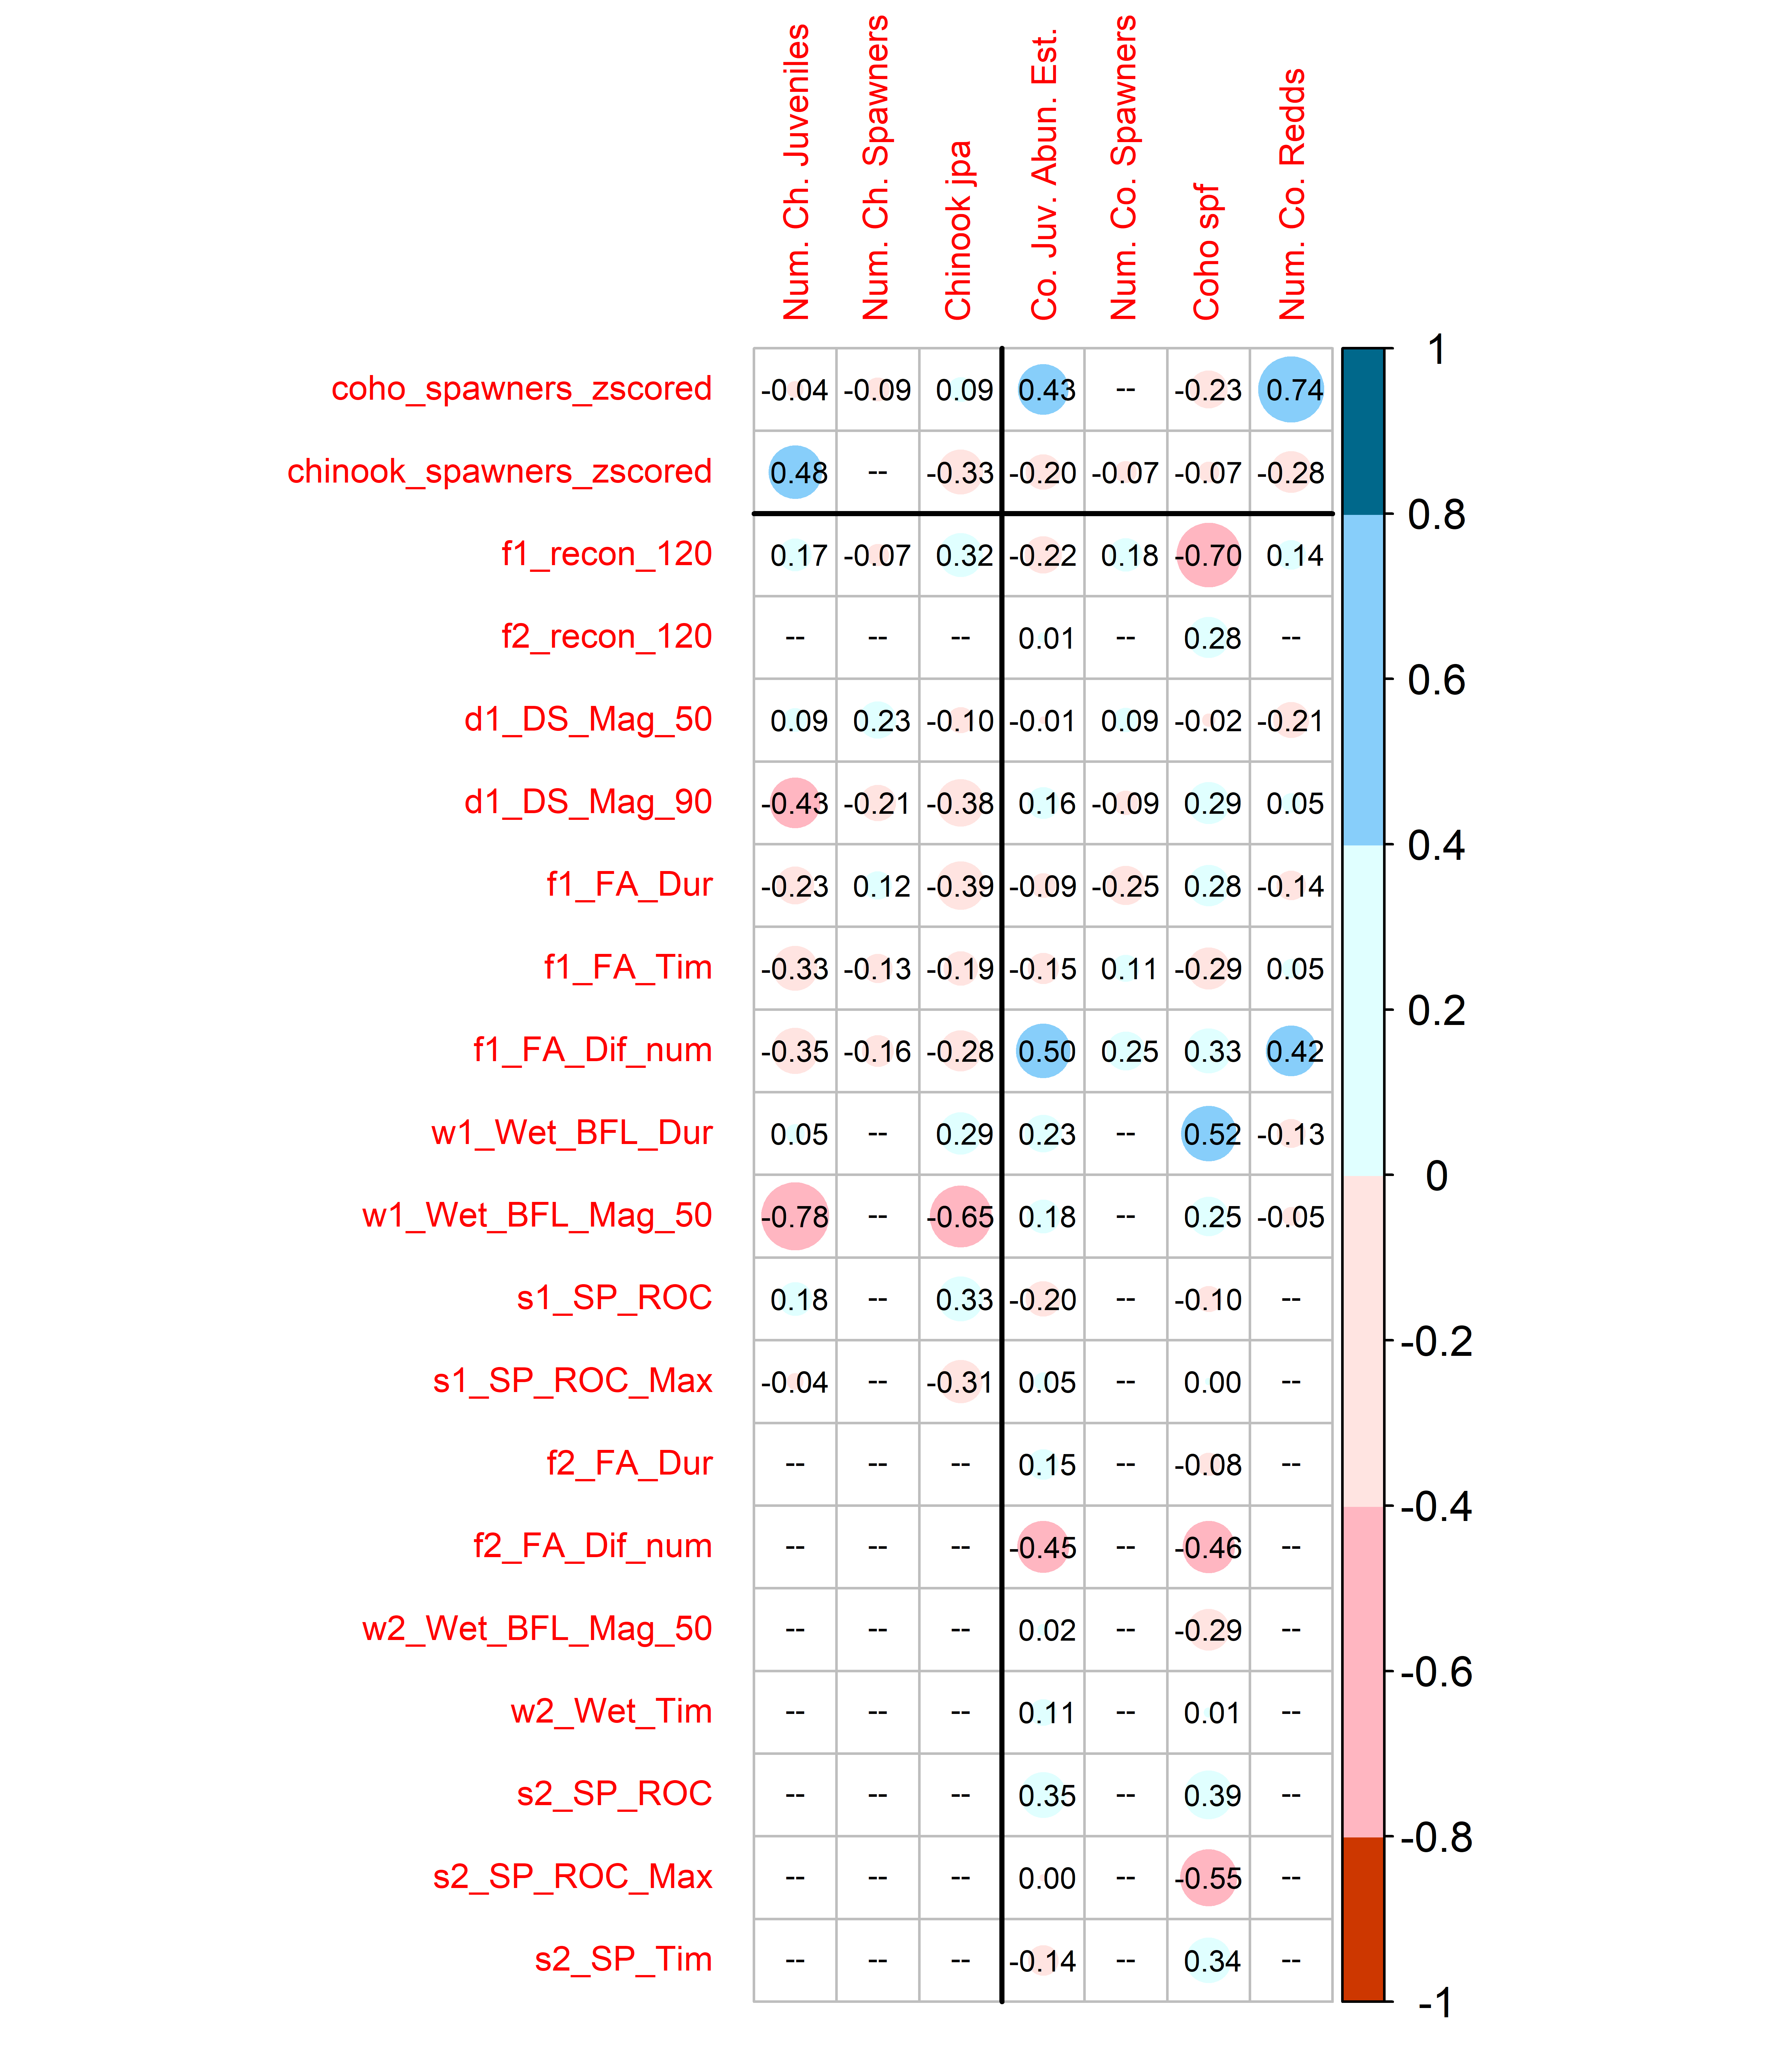

Figure 5: Correlations between 20 Z-scored predictors (2 spawner observation records and 18 hydrologic metrics, prescreened for collinearity) and 7 log-transformed ecological monitoring records for Chinook (left three columns) and coho (right four columns). Large blue circles indicate that the quantity (such as the first wet season median baseflow, or w1_Wet_BFL_Mag_50) is positively correlated with observed fish metrics. For dates, a blue dot indicates that a later date is correlated with higher fish values, while a red dot indicates that an earlier date is correlated with higher fish values. The full suite of calculated R values is shown in Supplemental Figure 1.

## 4.3 LASSO regression

* Full list for coho:
  + higher first dry season high flows,
  + earlier first fall reconnection,
  + longer first wet season,
  + higher first wet season average baseflow,
  + larger first fall flow increase,
  + smaller second fall flow increase,
  + slower first spring recession, and
  + faster second spring recession.
* Full list for Chinook:
  + higher top 10% of flows in the dry season,
  + earlier fall reconnection,
  + lower wet season baseflows,
  + longer wet season, and
  + slower maximum spring recession rate.

Coefficients

Table 2: Description of four different techniques for modeling two types ecological outcomes using hydrologic metrics (and available ecological data, if applicable).

| Predicts | Method | Most Important Hydrologic Metrics | | Hydrologic vs. Spawner Influence (Coef. Ratios) | |
| --- | --- | --- | --- | --- | --- |
|  |  | Coho | Chinook | Coho | Chinook |
| juveniles per adult | LASSO | Earlier first fall reconnection, longer first wet season, smaller second fall flow increase, faster second spring recession | Lower wet season baseflow, slower max. spring recession rate, longer wet season | (untested) | (untested) |
| juveniles per adult | MARSS | Earlier fall reconnection, larger first fall flow increase, greater first wet season baseflow | Greater dry season high flows, slower max. spring recession rate, earlier fall reconnection | (untested) | (untested) |
| juvenile abundance | LASSO | Larger first fall flow increase, smaller second fall flow increase, slower first spring recession | Lower wet season baseflow, (spawner abundance), slower max. spring recession, longer wet season | Greater hydro influence; Hydro-to-Spawner >8x | Greater hydro influence; Hydro-to-Spawner >2x |
| juvenile abundance | MARSS | Larger first fall flow increase, earlier fall reconnection, greater dry season high flows | Slower max. spring recession rate, lower wet season baseflow, earlier fall reconnection | ~Equivalent influence (Hydro-to-Spawner of 0.7 to 1.5) | Greater hydro influence; Hydro-to-Spawner of 1.7 to 6.3 |

### 4.3.1 Cross-validation and selection of penalty value (lambda)

* cross-validation using $k$ folds, in which the data is split into to test and training data sets. default number of folds is 10; reduced number of folds to the maximum number in which the number of observations per fold was greater than 3.

## Warning: Option grouped=FALSE enforced in cv.glmnet, since < 3 observations per  
## fold  
## Warning: Option grouped=FALSE enforced in cv.glmnet, since < 3 observations per  
## fold

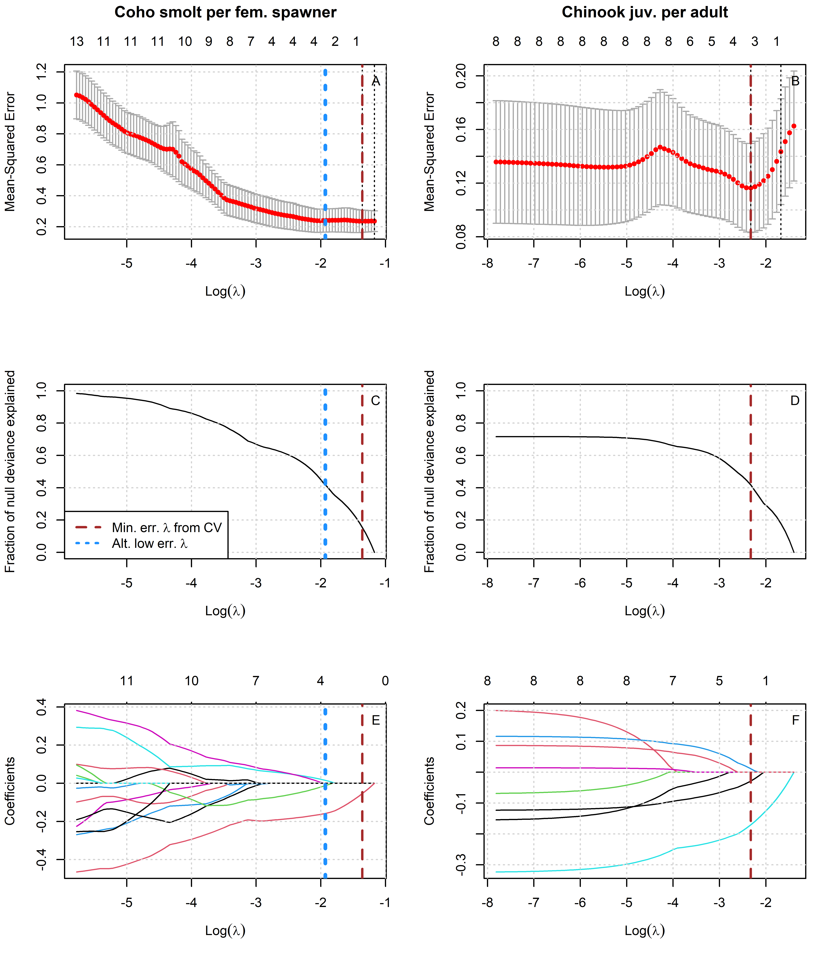

Figure 6: Results of LASSO regression to predict log-transformed coho and Chinook outcomes with Z-scored hydrologic metrics. Models with more coefficients explain a greater fraction of deviance in the dataset (middle panel), but also produce higher test errors (top panel), indicating some overfitting at lower lambda values. Higher values of lambda tend to shrink the absolute values of regression coefficients toward 0 (bottom panel).

### 4.3.2 Test error and selection of final lambda value

### 4.3.3 Regression coefficients and fraction of deviation (full dataset)

To explain 20% of Chinook deviation, the regression model needed 5 non-0 coefficients (or degrees of freedom), while for coho only 1 was necessary. Similarly, to explain 50% of variation required 8 and 5 degrees of freedom for Chinook and coho respectively (Figures ?? and ??, middle panel).

## 4.4 Hydrologic Benefit Function

For each species, the predictive model of ecological observations was based on the selected final lambda values, and refered to as the Hydrologic Benefit (HB) function. The HB function for coho is composed of an intercept and five non-zero coefficients, while for Chinook it includes only one non-zero coefficient (Tables 3 and 4).

Table 3: Values for the intercept and coefficient terms in the Hydrologic Benefit function for coho spf, including a description of which phenomena are associated with higher ecological outcome values.

| Predictor | Value | Greater Hydrologic Benefit value associated with |
| --- | --- | --- |
|  | 1.592 | (Intercept) |
| f1_recon_120 | -0.158 | Earlier fall reconnection (during parents' spawning) |
| w1_Wet_BFL_Dur | 0.016 | Longer wet season (as eggs and hatchlings) |
| f2_FA_Dif_num | -0.012 | Smaller fall pulse (as juvenile fish) |

Table 4: Values for the intercept and coefficient terms in the Hydrologic Benefit function for Chinook juvenile abundance, including a description of which phenomena are associated with higher ecological outcome values.

| Predictor | Value | Greater Hydrologic Benefit value associated with |
| --- | --- | --- |
|  | 1.946 | Intercept |
| w1_Wet_BFL_Mag_50 | -0.171 | Lower wet season baseflows (first wet season, as eggs and fry) |
| s1_SP_ROC_Max | -0.029 | Slower max. spring recession rate (as outmigrating smolt) |
| w1_Wet_BFL_Dur | 0.011 | Longer wet season (as eggs and fry) |

### 4.4.1 Predictors and coefficients in the selected models

The predictive model of coho spf included one positive coefficient, for predictor RY_discon_200. This indicates that delayed river disonnection in the spring is related to higher relative coho reproduction. All other coeficients are negative, including three metrics related to reconnection timing, indicating that earlier reconnections at the end of the dry season are related to higher relative coho reproduction. The range of flow values indicate possibly differential sensitivity to different flow phenomena: 8 cfs only occurs at the end of a very dry water year, while 120 cfs typically means that coho salmon have access to some of their preferred tributary habitat (Siskiyou County 2021). One coefficient is somewhat counterintutive, suggesting that a higher rearing year dry season flow magnitude is associated with reduced coho reproduction; in our experience we would expect the opposite to be true.

The predictive model of Chinook jpa contains one non-zero coefficient, which is associated with predictor log_by_tot_flow_sepdec. This suggests that the order-of-magnitude of brood year total flow is negatively related to relative reproduction of Chinook. It’s possible that this relationship is driven by high-flow events in wet years that could produce scouring flows, negatively impacting Chinook eggs laid in the mainstem of the Scott River.

### 4.4.2 Predicted Hydrologic Benefit value over time

The visual match between predicted and observed values for coho spf is rather poor: predicted values do not range either as low or as high as observed values (Figure 7, top panel). This matches the expectation that the selected regression model will explain only ~50% of the deviation from the mean (Figure ??, middle panel). The visual match for Chinook, however, is significantly worse (Figure 7, lower panel), corresponding to a regression model that explains <10% of deviation (Figure ??, middle panel).

Matching the historical flow trends discussed above (and tabulated in *Supplemental Table 2*), the predicted value of coho spf-equivalent produced by a given water year has trended downward over time (Figure 7, top panel). The lowest predicted value, 12.1 coho spf in brood year 2013, corresponds to the severe drought year of 2014. Conditions were so extreme in water year 2014 that emergency measures were taken by local agencies and conservation organizations to facilitate transport of salmon around disconnected river reaches (CDFW et al. 2015).

Conversely, for Chinook, because such an inflexible model was selected, no trend is visible in predicted values (Figure 7, lower panel).

## png   
## 2

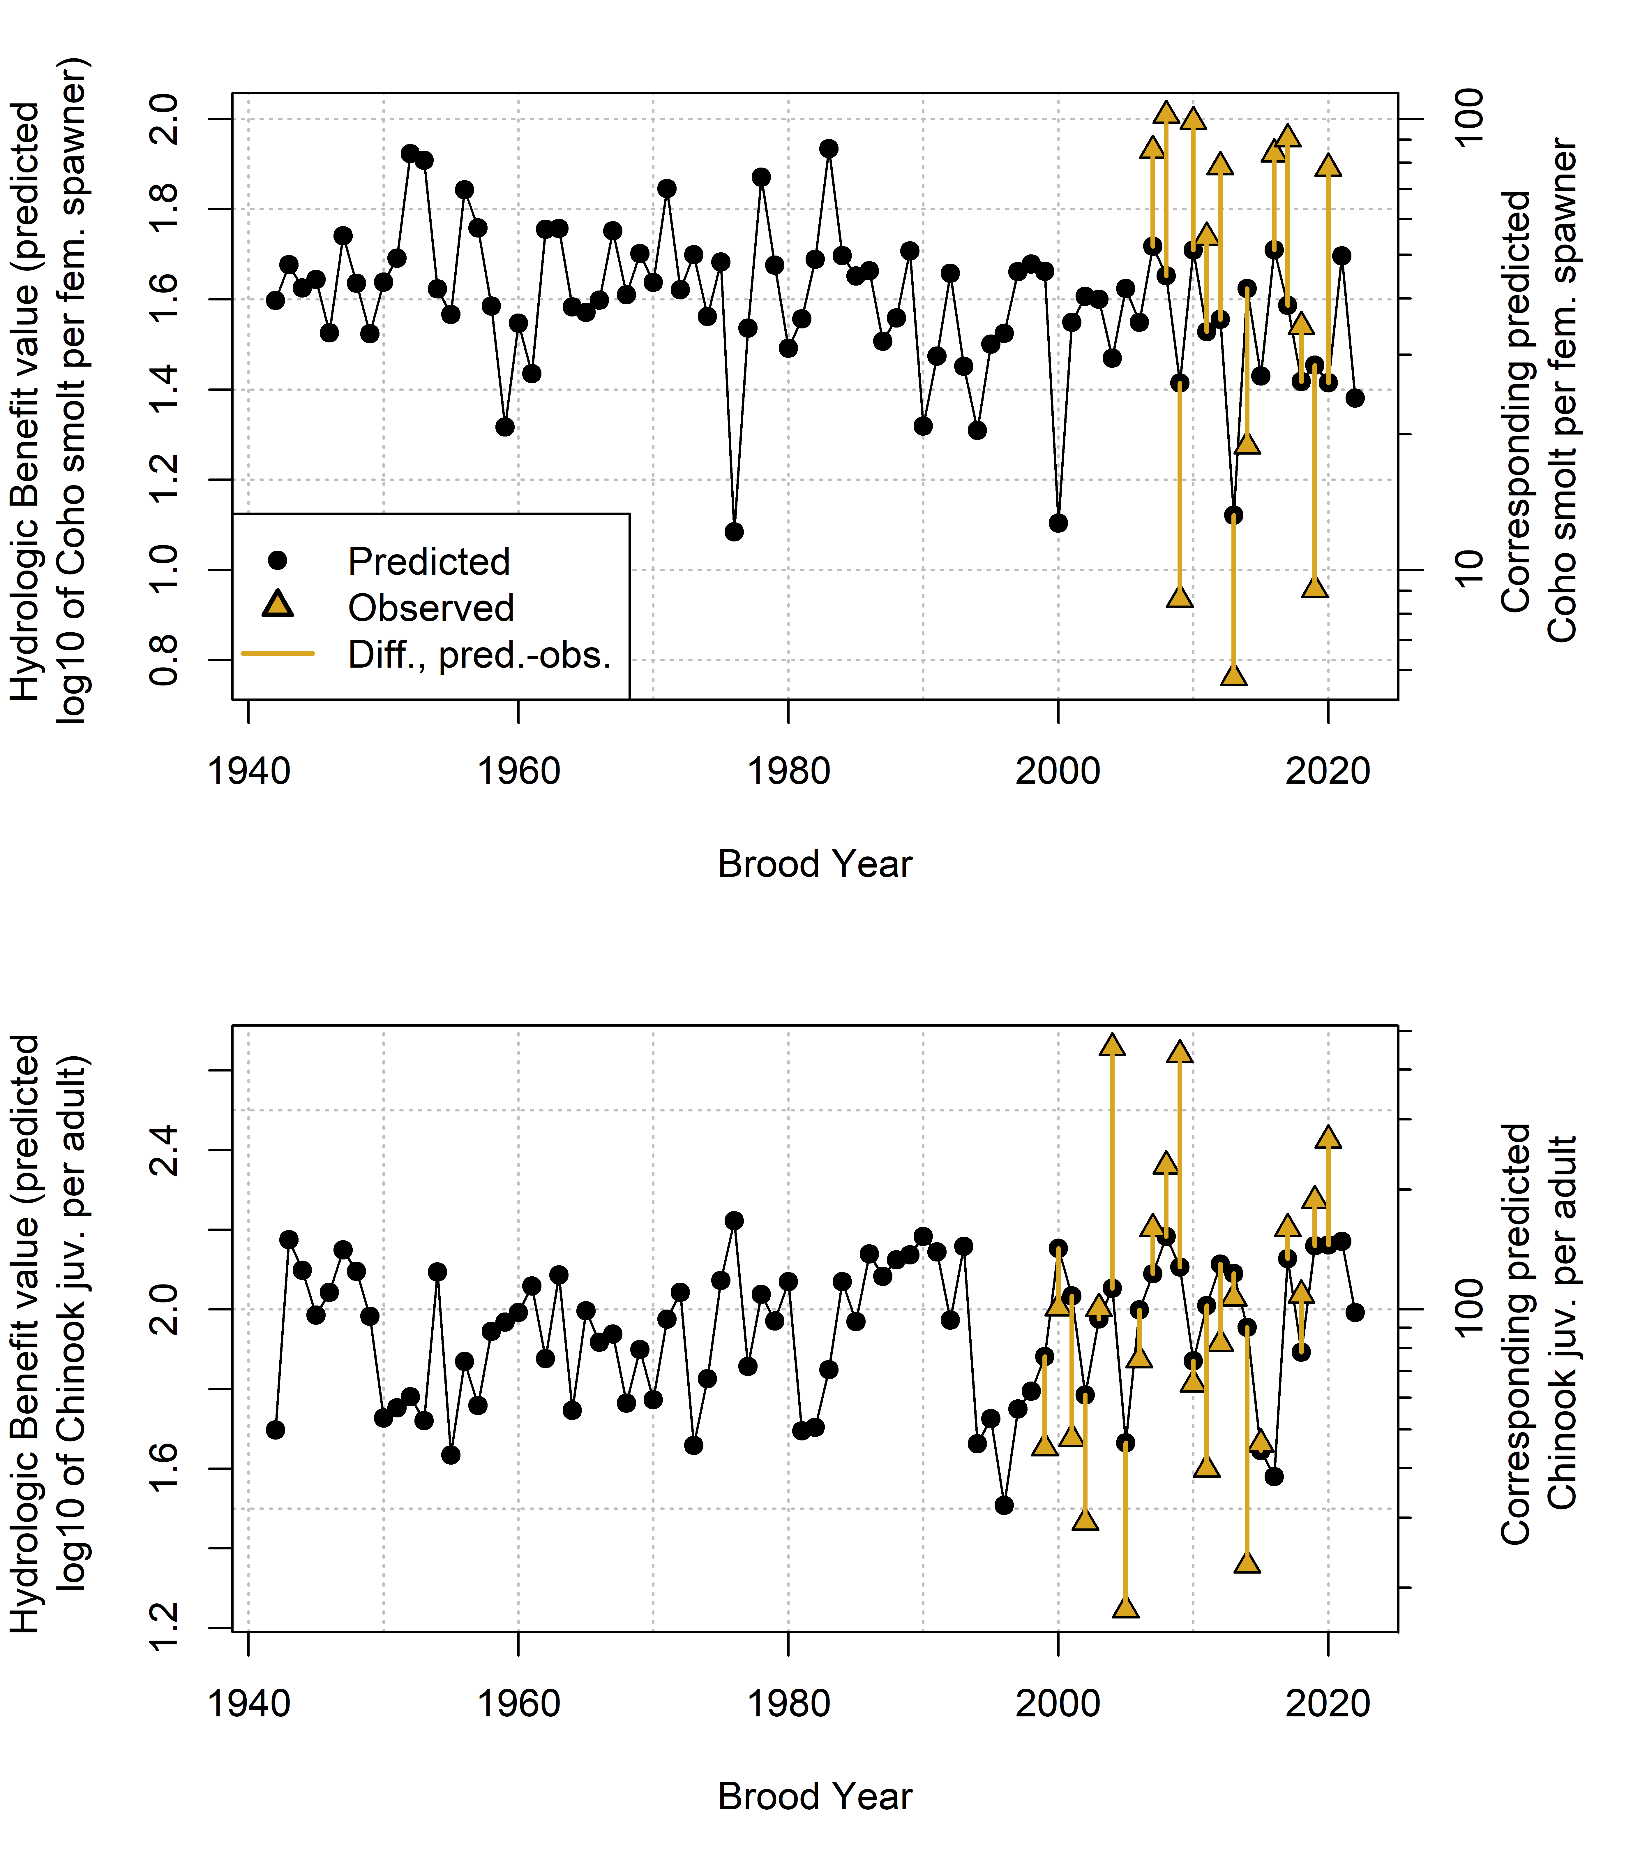

Figure 7: Annual observed and predicted values of coho smolt produced per female spawner (coho spf, top panel) and Chinook juveniles produced per adult spawner (Chinook jpa, lower panel). Predicted quantities (black dots) are shown as Hydrologic Benefit (HB) function values. The predicted and observed values are plotted by each cohort’s Brood Year.

### 4.4.3 Hydrologic Benefit function component contributions

The predicted HB values can be broken out into the value contributed by each predictor (Figure 8; the intercept term is excluded for ease of visualization). For coho spf, the largest contributions are from brood year fall reconnection timing (BY_recon_200 and BY_recon_100); a negative value indicates that earlier reconnection timing is associated with higher relative smolt production. The next largest contribution is from spring disconnection in the rearing year: higher smolt production is predicted from later disconnection timing. Two other predictors, RY_recon_8 and RY_DS_Mag_90 contribute only minor amounts, although occasionally, in years with very low dry season flow and delayed fall reconnections, predictor RY_recon_8 contributes a meaningful negative value (Figure 8, top panel). For Chinook, all variation is introduced by the predictor log_BY_tot_flow_sepdec, since the model includes only one non-zero coefficient.

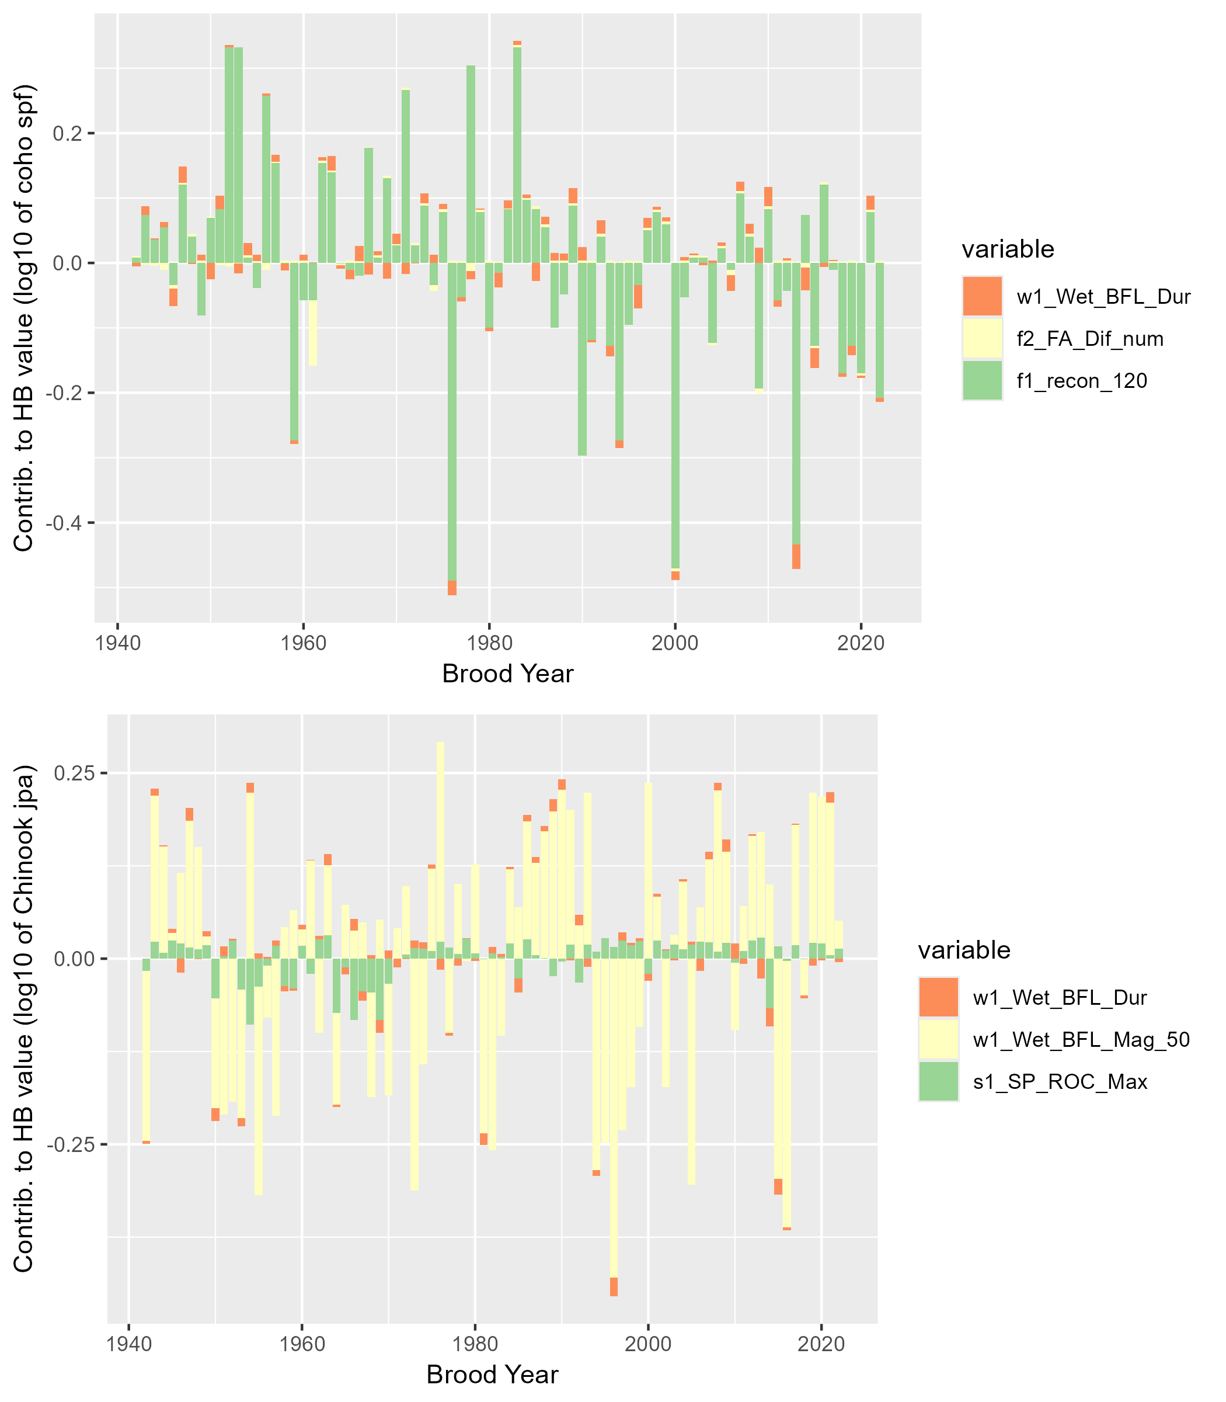

Figure 8: Contributions to annual Hydrologic Benefit values (coho spf-equivalent, top panel, and Chinook jpa-equivalent, lower panel). A positive value indicates that a greater quantity contributes a positive value to the predicted ecological outcome in that cohort (e.g., a later spring disconnection produces more predicted coho spf). A negative value indicates that a larger number contributes a negative value to the predicted outcome (e.g., a later fall reconnection date produces fewer predicted coho spf in that cohort).

# 5 Discussion

While the primary aim of this paper (as described in Tredennick et al. 2021) is to develop a predictive model of ecological responses to flow, we can make some interpretations as to the mechanisms behind these predictions from the parameters of this model, which are interrogated further below. **forecasting papers** (Dietze et al. 2018) (Pennekamp et al. 2017) (Daugaard et al. 2022)

**life history based mgmt** fall pulse (attractant) flows can have a positive or negative effect on salmonids depending on life stage or timing (Nislow and Armstrong 2012) * water temperature particularly important. * High flows after hatching can make it difficult to avoid being swept downstream or to foraging effectively (Nislow and Armstrong 2012) * Parr seem to be less vulnerable to flow events than fry, and they spend more time sheltering (Nislow and Armstrong 2012). Regulating flows can effect conditions for parr growth. * Smolts outmigrate on the descending limb of a spring hydrograph; higher spring flows may lead to more rapid outmigration (and thus less opportunity for mortality in transit) (**McCormickEtAl1998?**)

The findings described above suggest that, in this case study, hydrology can explain about half of the variation in a key ecological outcome for coho salmon, though as a predictive tool it has some limitations.

## 5.1 Previous work and limitations of a hydrologic predictor approach

In many previous studies of flow-ecology relationships (especially related to fisheries), predictors used to model the ecological response are flow-derived metrics, because flow data is often continuous and more abundant than other data types. Such models rely on the assumption that flow, directly or as a proxy for other variables (e.g., habitat) is the limiting factor in ecological recruitment, and thus that changes in flow can be directly translated to a population response. However, this ignores ecological theory. Under many circumstances, complex internal population feedbacks (such as high juvenile fish density leading to some juvenile fish mortality) or community dynamics (food webs) will be the limiting factors on fish population size. Consequently, many authors have argued that models of fish population responses to hydrologic changes should explicitly include ecological population modeling in addition to physical factors such as flow or geomorphology (Rosenfeld 2003; Anderson et al. 2006; Lancaster and Downes 2010; Acreman et al. 2014; Shenton et al. 2012). Additionally, in at least one case, fish population differences were not successfully predicted with a model based only on flow metrics; other variables such as water temperature were necessary to capture population shifts (McManamay et al. 2013).

In spite of these known limitations, the HB function proposed here uses only hydrologic predictors. In part this is a pragmatic approach, as this work is intended to set the foundation for assessing flow conditions in speculative hydrologic models, which do not simulate non-hydrologic, ecologically-relevant factors such as water quality or internal population dynamics. Furthermore, previous work suggests that seasonal flow availability is a major limiting factor on the local coho salmon fishery, supporting the hydrologic predictor only approach in this case (SRWC and Siskiyou RCD 2005; NMFS 2014). Lastly, the proposed HB function avoids some of the disadvantages of the snapshot method of comparing the two states of natural and altered flows (Wheeler, Wenger, and Freeman 2018), because the hydro-ecological dataset is relatively long. This temporal structure, covering a wide range of water year types, makes it possible to test the hypothesis that a measurable relationship exists between hydrologic signal and ecologic response, even within an otherwise more complex relationship involving many non-hydrologic factors.

## 5.2 Correlations and predictor selection results suggest potential mechanisms for flow-ecology relationships

The correlation and predictor selection analyses support several findings (wet season duration, scouring flows, fall flow timing and outmigrants) that match existing understanding of coho ecohydrology, as well as one finding (fall flow timing and spawners) that does not match the current understanding. Mechanisms supporting some flow-ecology relationships are discussed below.

Experiencing a longer wet season as newly hatched fry (RY_Wet_BFL_Dur, or rearing year wet season baseflow duration) is associated with higher juvenile abundance for both species (Figure 5). Relatedly, a later rearing year dry season onset, and a later spring disconnection (in both the rearing and smolt years) are also associated with more outmigrating coho smolt. These correlations suggest that a longer initial wet season has a beneficial effect on the hatching cohort. Additionally, a higher number of RY scouring days seems to be related to lower Chinook outmigrants, whereas it has no relationship with coho outmigrants, matching the understanding of which species’ preferred habitat types are more vulnerable to scouring.

Additionally, in one of the strongest correlation signals, earlier fall reconnection timing (earlier fall spawning flows) is associated with higher coho spf. In general, earlier fall flows in the brood year are thought to be beneficial to coho salmon, but here it appears that this is only true for the absolute number of outmigrating juveniles. Corroborating the correlation results, among the predictors selected by LASSO regression, metrics contributing the most to predicted coho spf values occur during the window of their parents’ spawning (BY_recon_200 and BY_recon_100) and, to a lesser extent, in the spring and fall of their rearing year (RY_discon_200 and RY_recon_8) (Figure 8). This supports an interpretation that spawning conditions may exert a significant influence on the mortality rates of the hatching juveniles. One potential mechanism is that during dry water years, when fall reconnection dates are delayed, coho have been known to spawn in suboptimal habitat (e.g., Magranet 2015b). Eggs laid in suboptimal conditions suffer from higher mortality rates for multiple reasons, including egg burial by transported sediment, channel bed scouring, or unfavorable water quality (Bjornn and Reiser 1991). In wetter years, early reconnection flows and related access to more and higher-quality habitat may allow spawning salmon to select more favorable nesting sites.

However, a higher number of *spawners* is in fact associated with *later* fall flows (Figure 5). Relatedly and consistent with these results, the total flow volume in the four months of the brood year period is also negatively correlated with the number of coho spawners. An explanation for this counterintuitive finding may be beyond the scope of the present study: the correlation for later flow-spawner correlation is weaker than for early flow-juveniles, and the returning spawners may also be affected by ocean conditions. In any case, these findings suggest that earlier fall reconnection may allow the spawning population the best opportunity for reproductive success.

## 5.3 Reconnection at different flow thresholds may represent distinct ecological events

In this watershed, flow thresholds at the Fort Jones gauge can be closely tied to physical access for spawning. Salmon passage to access the lower mainstem is possible at a Fort Jones flowrate of ~20-40 cfs (though this is subject to some debate), while access to upper tributaries is generally associated with a Fort Jones flowrate of >100 cfs (*pers. comm.*, **Sommarstrom2020?**). The fact that the LASSO method identified multiple flow thresholds in the coho spf model suggests that the coho may experience these different degrees of river connectivity and/or flow conditions as events with different ecological consequences.

The river reconnection dates of multiple flow thresholds are correlated with each other and, to varying degrees, with biological monitoring data (see Results). The correlations with ecological observations support the current scientific understanding that the timing of restoration of habitat connectivity after dry periods in the Scott River is related to the reproductive success of spawning salmon (e.g., Siskiyou County 2021; SRWC 2018). However, the details, such as which specific numerical flow threshold was identified as the most important in the minimization of the equation in Section 3.6.1, are probably somewhat artifactual and would be sensitive to the addition of new future data points.

## 5.4 Differences in model flexibility possibly driven by biology

At a given relative test error, the Chinook model explains a smaller fraction of deviation than the coho model (Figures ?? and ??). This could be interpreted as a meaningful finding; i.e., it may be due to Chinook being less sensitive than coho to flow conditions. Or, it could be a statistical artifact: the Chinook model, with a larger sample size, may produce higher relative test errors in general. Given the size of the difference between the species (i.e., five non-zero coefficients for coho at 1.0 relative test error versus one for Chinook), it is possible both effects are present.

If we adopt the interpretation that hydrologic metrics have a greater capacity to predict relative reproduction in coho salmon than in Chinook, this difference can be attributed to any number of distinctions in the life history and reproductive strategies of the two species (see Section 2.2.4). Some possibilities include:

* Chinook prefer larger spawning gravels found on the mainstem of the Scott River, while coho salmon prefer smaller tributary streams, meaning that coho salmon must travel farther through the stream system to access their preferred spawning habitat. Consequently, coho salmon may be more sensitive to the amount and timing of river connectivity during their spawning window.
* Chinook populations tend to be larger than coho, which could mean they are more limited by internal population dynamics, while coho reproduction limits may be more determined by flow conditions.
* Chinook typically do not oversummer in the freshwater system, potentially making them less vulnerable than coho to dry season conditions.
* Chinook populations may be more strongly affected by ocean conditions than coho salmon, possibly due to behavior differences during their period of ocean residence, which is not examined here. This factor may exert a more powerful control on the number of returning spawners than freshwater conditions.

Regardless of the ultimate cause(s), this difference in predictability underscores the fact that the prediction exercise undertaken in this study can only be performed successfully for some species and some regions.

## 5.5 Implications for water and fisheries management

This study contributes a novel approach and insights to the large body of work seeking to understand and conserve aquatic ecosystems in the Klamath basin, and in aquatic ecosystems in Mediterranean climates more generally. The threshold of a 1.0 average relative test error generated a much more flexible model for coho spf than for Chinook jpa (Tables 3 and 4). The Chinook model has virtually no utility for predicting salmon outcomes (Figure 7); therefore, only the coho model will be evaluated as a predictive tool.

The predictive exercise for coho spf suggests that using flow alone to predict fish outcomes involves non-negligible uncertainties: HB function error terms (predicted minus observed values) are substantial (Figure 7). The coho spf HB function can somewhat accurately indicate a high or a low year (if we define the boundary between the two domains as 55 coho spf), though the range of predictions does not match the variability in the observations. This is partly a consequence of LASSO regression imposing a penalty on model flexibility, and represents a conservative estimate of the degree of variation in ecological outcomes that can be explained with flow metrics.

At a regional scale, this predictive tool could be used to assess simulated hydrologic outcomes of management actions in terms of the direct effect they would have on coho salmon reproduction. If used in that context, its limitations should be highlighted, including its average test error (100% of the average coho spf observation) and the fact that the hydrology explains only about 50% of the variation in the ecological data.

We expect that the proposed approach could be employed in other regional studies, though in systems with shorter or minimal ecological monitoring records, opportunities to find correlations between flow and biological metrics may be sample size-limited to an even greater degree than in this study. However, this study may show the value of even a dozen years of monitoring data in a range of water year types, and could provide motivation to continue investing in data collection and the monitoring of sensitive species.

# 6 Conclusions

This case study uses the functional flow framework and long-term biological monitoring to relate hydrologic conditions to watershed-scale anadromous fish reproduction rates. The empirical flow-biology relationships evaluated here also suggest hypotheses regarding the watershed- and species-specific mechanisms of ecological response to flow variability.

To learn if it was possible to empirically quantify a hydrologic regime that meets the ecological needs of coho salmon in the Scott River watershed, we examined correlations between several dozen hydrologic metrics and local salmon observations. We found several metrics, both from prior studies (Patterson et al. 2020; Yarnell et al. 2020) and designed for this study (e.g. Figure 11), that appeared correlated with the number of coho smolts produced per female spawner (coho spf) and the number of Chinook juveniles produced per adult spawner (Chinook jpa) (Figure 5). The metrics contributing the most to predicted coho spf values occur during the window of their parents’ spawning and, to a lesser extent, in the spring and fall of their rearing year (Figure 8). This supports an interpretation that spawning conditions may exert a significant influence on the mortality rates of the hatching juveniles.

Using LASSO regression, we calculated a predictive model of annual normalized reproduction for each salmon species (Figures ?? and ??). With a relative test error threshold of 1.0, the model for Chinook was virtually useless as a predictive tool. Conversely, the model for coho could explain about 50% of the variation in the ecological data. This suggests that the utility of this type of analysis is both region- and species-dependent.

With continuing trends of a narrowing wet season in the Scott River watershed (e.g., Figure 4), entities aiming to sustain local fisheries may find themselves working with ever-thinner margins for error. Globally, in communities living and working with local natural resources, climate change may transform biodiversity-preservation activities into long-term engineering of novel ecosystems. If this occurs, long-term monitoring and frequently re-evaluated flow-ecology relationships will be necessary to support such efforts.

# 7 References

Acero Triana, Juan S., Maria L. Chu, and Jeffrey A. Stein. 2021. “Assessing the Impacts of Agricultural Conservation Practices on Freshwater Biodiversity Under Changing Climate.” *Ecological Modelling* 453 (August): 109604. <https://doi.org/10.1016/j.ecolmodel.2021.109604>.

Acreman, Mike, Angela H. Arthington, Matthew J Colloff, Carol Couch, Neville D Crossman, Fiona Dyer, Ian Overton, Carmel A Pollino, Michael J Stewardson, and William Young. 2014. “Environmental Flows for Natural, Hybrid, and Novel Riverine Ecosystems in a Changing World.” *Frontiers in Ecology and the Environment* 12 (8): 466–73. <https://doi.org/10.1890/130134>.

Agrawal, A, R S Schick, E P Bjorkstedt, R G Szerlong, M N Goslin, B C Spence, T H Williams, and K M Burnett. 2005. “PREDICTING THE POTENTIAL FOR HISTORICAL COHO, CHINOOK AND STEELHEAD HABITAT IN NORTHERN CALIFORNIA.” National Marine Fisheries Service.

Alomía Herrera, Ilia, and Patricia Carrera Burneo. 2017. “Environmental Flow Assessment in Andean Rivers of Ecuador, Case Study: Chanlud and El Labrado Dams in the Machángara River.” *Ecohydrology & Hydrobiology* 17 (2): 103–12. <https://doi.org/10.1016/j.ecohyd.2017.01.002>.

Anderson, Kurt E., Andrew J. Paul, Edward McCauley, Leland J. Jackson, John R. Post, and Roger M. Nisbet. 2006. “Instream Flow Needs in Streams and Rivers: The Importance of Understanding Ecological Dynamics.” *Frontiers in Ecology and the Environment* 4 (6): 309–18. [https://doi.org/10.1890/1540-9295(2006)4[309:IFNISA]2.0.CO;2](https://doi.org/10.1890/1540-9295(2006)4%5b309:IFNISA%5d2.0.CO;2).

Arriana Brand, L., Juliet C. Stromberg, David C. Goodrich, Mark D. Dixon, Kevin Lansey, Doosun Kang, David S. Brookshire, and David J. Cerasale. 2011. “Projecting Avian Response to Linked Changes in Groundwater and Riparian Floodplain Vegetation Along a Dryland River: A Scenario Analysis.” *Ecohydrology* 4 (1): 130–42. <https://doi.org/10.1002/eco.143>.

Arthington, Angela H. 2012. *Environmental Flows: Saving Rivers in the Third Millennium*. Freshwater Ecology Series 4. Berkeley, CA: University of California Press. <https://doi.org/10.1525/9780520953451>.

Arthington, Angela H., J. M. Bernardo, and M. Ilhéu. 2014. “TEMPORARY RIVERS: LINKING ECOHYDROLOGY, ECOLOGICAL QUALITY AND RECONCILIATION ECOLOGY.” *River Research and Applications* 30 (10): 1209–15. <https://doi.org/10.1002/rra.2831>.

Ayllón, Daniel, Graciela G. Nicola, Irene Parra, Benigno Elvira, and Ana Almodóvar. 2014. “Spatio-Temporal Habitat Selection Shifts in Brown Trout Populations Under Contrasting Natural Flow Regimes.” *Ecohydrology* 7 (2): 569–79. <https://doi.org/10.1002/eco.1379>.

Bellido-Leiva, F. J., Robert A. Lusardi, and Jay R. Lund. 2021. “Modeling the Effect of Habitat Availability and Quality on Endangered Winter-Run Chinook Salmon (Oncorhynchus Tshawytscha) Production in the Sacramento Valley.” *Ecological Modelling* 447 (May): 109511. <https://doi.org/10.1016/j.ecolmodel.2021.109511>.

Bjornn, T. C., and D. W. Reiser. 1991. “Influences of Forest and Rangeland Management on Salmonid Fishes and Their Habitats.” *Influences of Forest and Rangeland Management on Salmonid Fishes and Their Habitats, Edited by W. R. Meehan (Special Publication)* 1991: 83–138. <https://doi.org/10.2307/1446234>.

Booth, Derek B., Yantao Cui, Zooey Diggory, Dirk Pedersen, Jordan Kear, and Michael Bowen. 2014. “Determining Appropriate Instream Flows for Anadromous Fish Passage on an Intermittent Mainstem River, Coastal Southern California, USA.” *Ecohydrology* 7 (2): 745–59. <https://doi.org/10.1002/eco.1396>.

Bourret, Samuel L., Christopher C. Caudill, and Matthew L. Keefer. 2016. “Diversity of Juvenile Chinook Salmon Life History Pathways.” *Reviews in Fish Biology and Fisheries* 26 (3): 375–403. <https://doi.org/10.1007/s11160-016-9432-3>.

Bower, Luke M., Brandon K. Peoples, Michele C. Eddy, and Mark C. Scott. 2022. “Quantifying Flow–Ecology Relationships Across Flow Regime Class and Ecoregions in South Carolina.” *Science of The Total Environment* 802 (January): 149721. <https://doi.org/10.1016/j.scitotenv.2021.149721>.

Bradford, Michael J., Garth C. Taylor, and J. Andrew Allan. 1997. “Empirical Review of Coho Salmon Smolt Abundance and the Prediction of Smolt Production at the Regional Level.” *Transactions of the American Fisheries Society* 126 (1): 49–64. [https://doi.org/10.1577/1548-8659(1997)126<0049:EROCSS>2.3.CO;2](https://doi.org/10.1577/1548-8659(1997)126%3c0049:EROCSS%3e2.3.CO;2).

Bradley, D. C., M. J. Streetly, D. Cadman, M. Dunscombe, E. Farren, and A. Banham. 2017. “A Hydroecological Model to Assess the Relative Effects of Groundwater Abstraction and Fine Sediment Pressures on Riverine Macro-Invertebrates.” *River Research and Applications* 33 (10): 1630–41. <https://doi.org/10.1002/rra.3191>.

Brown, Larry R., Peter B. Moyle, and Ronald M. Yoshiyama. 1994. “Historical Decline and Current Status of Coho Salmon in California.” *North American Journal of Fisheries Management* 14 (2): 237–61. [https://doi.org/10.1577/1548-8675(1994)014<0237:HDACSO>2.3.CO;2](https://doi.org/10.1577/1548-8675(1994)014%3c0237:HDACSO%3e2.3.CO;2).

Brummer, T. J., A. E. Byrom, J. J. Sullivan, and P. E. Hulme. 2016. “A Quantitative Framework to Derive Robust Characterization of Hydrological Gradients: Framework for Robust Design of Flow-Ecology Studies.” *River Research and Applications* 32 (7): 1517–29. <https://doi.org/10.1002/rra.3001>.

Bunn, Stuart E., and Angela H. Arthington. 2002. “Basic Principles and Ecological Consequences of Altered Flow Regimes for Aquatic Biodiversity.” *Environmental Management* 30 (4): 492–507. <https://doi.org/10.1007/s00267-002-2737-0>.

Bustard, David R., and David W. Narver. 1975. “Aspects Ofthe Winter Ecology of Juvenile Coho Sahnon (Oncorhynchus Kisutch) and Steelhead Trout (Salmo Gairdneri).” *Journal of the Fisheries Resources Board of Canada* 32 (5): 667–80. <https://doi.org/10.1139/f75-086>.

California Department of Fish and Wildlife. 2015. “Recovery Strategy for California Coho Salmon Progress Report 2004 - 2012.”

———. 2021. “Scott River Best Available Scientific Information for Instream Flow Criteria.”

California Department of Fish and Wildlife, NOAA-Fisheries, Scott River Water Trust, Siskiyou Resource Conservation District, and U.S. Forest Service - Klamath National Forest. 2015. “Cooperative Scott River Coho Rescue & Relocation Effort: 2014 Drought Emergency.”

California Department of Water Resources. 2021. “Agricultural Land & Water Use Estimates.” https://water.ca.gov/Programs/Water-Use-And-Efficiency/Land-And-Water-Use/Agricultural-Land-And-Water-Use-Estimates.

Cartwright, Jennifer, Casey Caldwell, Steven Nebiker, and Rodney Knight. 2017. “Putting Flow–Ecology Relationships into Practice: A Decision-Support System to Assess Fish Community Response to Water-Management Scenarios.” *Water* 9 (3): 196. <https://doi.org/10.3390/w9030196>.

Catford, Jane A., William K. Morris, Peter A. Vesk, Christopher J. Gippel, and Barbara J. Downes. 2014. “Species and Environmental Characteristics Point to Flow Regulation and Drought as Drivers of Riparian Plant Invasion.” Edited by Jeffrey Diez. *Diversity and Distributions* 20 (9): 1084–96. <https://doi.org/10.1111/ddi.12225>.

Chowdhury, Shahadat, and Patrick Driver. 2007. “An Ecohydrological Model of Waterbird Nesting Events to Altered Floodplain Hydrology.” In *MODSIM 2007 International Congress on Modelling and Simulation*, 2896–2902. Modeling and Simulation Society of Australia and New Zealand.

Coordinated Resource Management Planning Committee, and Scott River Watershed Council. 2000. “FINAL REPORT.”

Daneshvar, Fariborz, Amir Pouyan Nejadhashemi, Matthew R. Herman, and Mohammad Abouali. 2017. “Response of Benthic Macroinvertebrate Communities to Climate Change.” *Ecohydrology & Hydrobiology* 17 (1): 63–72. <https://doi.org/10.1016/j.ecohyd.2016.12.002>.

Daugaard, Uriah, Stephan B. Munch, David Inauen, Frank Pennekamp, and Owen L. Petchey. 2022. “Forecasting in the Face of Ecological Complexity: Number and Strength of Species Interactions Determine Forecast Skill in Ecological Communities.” *Ecology Letters* 25 (9): 1974–85. <https://doi.org/10.1111/ele.14070>.

DeWeber, J. Tyrell, and James T. Peterson. 2020. “Comparing Environmental Flow Implementation Options with Structured Decision Making: Case Study from the Willamette River, Oregon.” *JAWRA Journal of the American Water Resources Association* 56 (4): 599–614. <https://doi.org/10.1111/1752-1688.12845>.

Dietze, Michael C., Andrew Fox, Lindsay M. Beck-Johnson, Julio L. Betancourt, Mevin B. Hooten, Catherine S. Jarnevich, Timothy H. Keitt, et al. 2018. “Iterative Near-Term Ecological Forecasting: Needs, Opportunities, and Challenges.” *Proceedings of the National Academy of Sciences* 115 (7): 1424–32. <https://doi.org/10.1073/pnas.1710231115>.

Dormann, Carsten F., Jane Elith, Sven Bacher, Carsten Buchmann, Gudrun Carl, Gabriel Carré, Jaime R. García Marquéz, et al. 2013. “Collinearity: A Review of Methods to Deal with It and a Simulation Study Evaluating Their Performance.” *Ecography* 36 (1): 27–46. <https://doi.org/10.1111/j.1600-0587.2012.07348.x>.

Drake, Daniel J., Kenneth W. Tate, and Harry Carlson. 2000. “Analysis Shows Climate-Caused Decreases in Scott River Fall Flows.” *California Agriculture* 54 (6): 46–49. <https://doi.org/10.3733/ca.v054n06p46>.

Escobar-Arias, M. I., and Gregory B. Pasternack. 2010. “A Hydrogeomorphic Dynamics Approach to Assess in-Stream Ecological Functionality Using the Functional Flows Model, Part 1—Model Characteristics.” *River Research and Applications* 26 (9): 1103–28. <https://doi.org/10.1002/rra.1316>.

Foglia, Laura, Alison McNally, Courtney Hall, Lauren Ledesma, Ryan Hines, and Thomas Harter. 2013. “Scott Valley Integrated Hydrologic Model: Data Collection, Analysis, and Water Budget.” Davis, CA: North Coast Regional Water Quality Control Board.

Franklin, Tom. 2012. “Scott River Adult Coho Spawning Ground Surveys 2011 Season.” Etna, CA: Siskiyou Resource Conservation District.

Friedman, Jerome, Trevor Hastie, and Robert Tibshirani. 2010. “Regularization Paths for Generalized Linear Models via Coordinate Descent.” *Journal of Statistical Software* 33 (1). <https://doi.org/10.18637/jss.v033.i01>.

Gao, Ye, Yong-hong Xie, and Dong-sheng Zou. 2020. “Hydrological Regime Change and Its Ecological Responses in East Dongting Lake, China.” *Ecohydrology & Hydrobiology* 20 (1): 142–50. <https://doi.org/10.1016/j.ecohyd.2019.07.003>.

Grantham, Ted, Jeffrey Mount, Eric D Stein, and Sarah M. Yarnell. 2020. “Making the Most of Water for the Environment: A Functional Flows Approach for California’s Rivers.” Public Policy Institute of California.

Groot, Cornelis, and Leo Margolis, eds. 1991. “Life History of Chinook Salmon (Onchorhynchus Tshawytscha).” In *Pacific Salmon Life Histories*. Vancouver: UBC Press.

Guareschi, S., A. Laini, E. Racchetti, T. Bo, S. Fenoglio, and M. Bartoli. 2014. “How Do Hydromorphological Constraints and Regulated Flows Govern Macroinvertebrate Communities Along an Entire Lowland River?” *Ecohydrology* 7 (2): 366–77. <https://doi.org/10.1002/eco.1354>.

Guedes, Gustavo Henrique Soares, Tailan Moretti Mattos, Geysa Da Silva Camilo, Wagner Uehara, Débora Lisandra De Paiva Ferreira, and Francisco Gerson Araújo. 2020. “Artificial Flow Regime Promotes Abiotic and Biotic Gradients: Testing the Concept of Longitudinal Zonation in an Off-River Reservoir.” *Ecohydrology & Hydrobiology* 20 (2): 256–64. <https://doi.org/10.1016/j.ecohyd.2020.02.002>.

Hain, Ernie F., Jonathan G. Kennen, Peter V. Caldwell, Stacy A. C. Nelson, Ge Sun, and Steven G. McNulty. 2018. “Using Regional Scale Flow–Ecology Modeling to Identify Catchments Where Fish Assemblages Are Most Vulnerable to Changes in Water Availability.” *Freshwater Biology* 63 (8): 928–45. <https://doi.org/10.1111/fwb.13048>.

Hale, Robin, Jian D. L. Yen, Charles R. Todd, Ivor G. Stuart, Henry F. Wootton, Jason D. Thiem, John D. Koehn, et al. 2023. “Is My Model Fit for Purpose? Validating a Population Model for Predicting Freshwater Fish Responses to Flow Management.” *Ecosphere* 14 (9): e4660. <https://doi.org/10.1002/ecs2.4660>.

Han, Ming, Chengyi Zhao, Gary Feng, Markus Disse, Fengzhi Shi, and Juyan Li. 2015. “An Eco-Hydrological Approach to Predicting Regional Vegetation and Groundwater Response to Ecological Water Conveyance in Dryland Riparian Ecosystems.” *Quaternary International* 380–381 (September): 224–36. <https://doi.org/10.1016/j.quaint.2015.02.032>.

Harter, Thomas, and Ryan Hines. 2008. “SCOTT VALLEY COMMUNITY GROUNDWATER STUDY PLAN.” University of California, Davis.

Herbst, David B., Scott D. Cooper, Robert Bruce Medhurst, Sheila W. Wiseman, and Carolyn T. Hunsaker. 2019. “Drought Ecohydrology Alters the Structure and Function of Benthic Invertebrate Communities in Mountain Streams.” *Freshwater Biology* 64 (5): 886–902. <https://doi.org/10.1111/fwb.13270>.

Hunt, Sharon L, Timothy J Mulligan, and Kenichiro Komori. 1999. “Oceanic Feeding Habits of Chinook Salmon, Oncorhynchus Tshawytscha, Off Northern Californi.” *Fishery Bulletin* 97 (3): 717–21.

Jager, Henriette I. 2014. “Thinking Outside the Channel: Timing Pulse Flows to Benefit Salmon via Indirect Pathways.” *Ecological Modelling* 273 (February): 117–27. <https://doi.org/10.1016/j.ecolmodel.2013.11.007>.

Jager, Henriette I., and Kenneth A. Rose. 2003. “Designing Optimal Flow Patterns for Fall Chinook Salmon in a Central Valley, California, River.” *North American Journal of Fisheries Management* 23 (1): 1–21. [https://doi.org/10.1577/1548-8675(2003)023<0001:DOFPFF>2.0.CO;2](https://doi.org/10.1577/1548-8675(2003)023%3c0001:DOFPFF%3e2.0.CO;2).

Jager, Henriette I., and Brennan T. Smith. 2008. “Sustainable Reservoir Operation: Can We Generate Hydropower and Preserve Ecosystem Values?” *River Research and Applications* 24 (3): 340–52. <https://doi.org/10.1002/rra.1069>.

James, Gareth, Daniela Witten, Trevor Hastie, and Robert Tibshirani. 2013. *An Introduction to Statistical Learning*. Vol. 103. Springer Texts in Statistics. New York, NY: Springer New York. <https://doi.org/10.1007/978-1-4614-7138-7>.

Kelson, Suzanne J., and Stephanie M. Carlson. 2019. “Do Precipitation Extremes Drive Growth and Migration Timing of a Pacific Salmonid Fish in Mediterranean-Climate Streams?” *Ecosphere* 10 (3): e02618. <https://doi.org/10.1002/ecs2.2618>.

Kevic, Maja, Johannes Ortlepp, Uta Mürle, and Christopher T. Robinson. 2018. “Effects of Experimental Floods in Two Rivers with Contrasting Valley Morphologies.” *Fundamental and Applied Limnology* 192 (2): 145–60. <https://doi.org/10.1127/fal/2018/1177>.

Knechtle, Morgan, and Domenic Giudice. 2020. “2019 SCOTT RIVER SALMON STUDIES FINAL REPORT.” California Department of Fish and Wildlife.

———. 2023. “2022 SCOTT RIVER SALMON STUDIES FINAL REPORT.” Yreka, CA: California Department of Fish and Wildlife.

Konrad, Christopher P., Julian D. Olden, David A. Lytle, Theodore S. Melis, John C. Schmidt, Erin N. Bray, Mary C. Freeman, et al. 2011. “Large-Scale Flow Experiments for Managing River Systems.” *BioScience* 61 (12): 948–59. <https://doi.org/10.1525/bio.2011.61.12.5>.

Kouba, Claire, and Thomas Harter. 2024. “Seasonal Prediction of End-of-Dry-Season Watershed Behavior in a Highly Interconnected Alluvial Watershed in Northern California.” *Hydrology and Earth System Sciences* 28 (3): 691–718. <https://doi.org/10.5194/hess-28-691-2024>.

Lamouroux, Nicolas, and Jean-Michel Olivier. 2015. “Testing Predictions of Changes in Fish Abundance and Community Structure After Flow Restoration in Four Reaches of a Large River ( F Rench R hône).” *Freshwater Biology* 60 (6): 1118–30. <https://doi.org/10.1111/fwb.12324>.

Lancaster, Jill, and Barbara J. Downes. 2010. “Linking the Hydraulic World of Individual Organisms to Ecological Processes: Putting Ecology into Ecohydraulics.” *River Research and Applications* 26 (4): 385–403. <https://doi.org/10.1002/rra.1274>.

Larsen, Stefano, Bruno Majone, Patrick Zulian, Elisa Stella, Alberto Bellin, Maria Cristina Bruno, and Guido Zolezzi. 2021. “Combining Hydrologic Simulations and Stream-Network Models to Reveal Flow-Ecology Relationships in a Large Alpine Catchment.” *Water Resources Research* 57 (4): e2020WR028496. <https://doi.org/10.1029/2020WR028496>.

Lueders, Mark B., and Ryan A. McManamay. 2023. “Species Depletion Profiles as an Alternative to Streamflow Alteration Thresholds in a Hydroecological Risk Assessment.” *Ecological Indicators* 147 (March): 109989. <https://doi.org/10.1016/j.ecolind.2023.109989>.

Mack, Seymour. 1958. “Geology and Ground-Water Features of Scott Valley, Siskiyou County, California.” Geological {{Survey Water-Supply Paper}} 1462. United States Geological Survey. <https://doi.org/10.3133/wsp1462>.

Magranet, Lindsay. 2015a. “Scott River Fall Chinook Spawning Ground Surveys.” Etna, CA: Siskiyou Resource Conservation District.

———. 2015b. “Scott River Adult Coho Spawning Ground Surveys 2014-2015 Season.” Etna, CA: Siskiyou Resource Conservation District.

———. 2017. “Scott River Fall Chinook Spawning Ground Surveys.” Etna, CA: Siskiyou Resource Conservation District.

———. 2018a. “Scott River Fall Chinook Spawning Ground Surveys 2017 Season.” Etna, CA: Siskiyou Resource Conservation District.

———. 2018b. “2017 Monitoring Report.” Scott River Water Trust.

Magranet, Lindsay, and Erich Yokel. 2017. “Scott River Adult Coho Spawning Ground Surveys 2016-2017 Season.” Etna, CA: Siskiyou Resource Conservation District.

Mansfield, Carol, George Van Houtven, Amy Hendershott, Patrick Chen, Jeremy Porter, Vesall Nourani, and Vikram Kilambi. 2012. “Klamath River Basin Restoration Nonuse Value Survey.”

Massie, Margaret, and Harrison Morrow. 2021. “2020 SCOTT RIVER JUVENILE SALMONID OUTMIGRANT STUDY.” California Department of Fish and Wildlife.

Maurer, Sue. 2003. “Scott River Watershed Adult Coho Salmon Spawning Survey.” Etna, CA: Siskiyou Resource Conservation District.

Mazor, Raphael D., Jason T. May, Ashmita Sengupta, Kenneth S. McCune, Brian P. Bledsoe, and Eric D. Stein. 2018. “Tools for Managing Hydrologic Alteration on a Regional Scale: Setting Targets to Protect Stream Health.” *Freshwater Biology* 63 (8): 786–803. <https://doi.org/10.1111/fwb.13062>.

McMahon, Thomas E. 1983. “Habitat Suitability Index Models: Coho Salmon.” FWS/OBS-82/10.49. U.S. Fish and Wildlife Service.

McManamay, Ryan A., and Emmanuel A. Frimpong. 2015. “Hydrologic Filtering of Fish Life History Strategies Across the United States: Implications for Stream Flow Alteration.” *Ecological Applications* 25 (1): 243–63. <https://doi.org/10.1890/14-0247.1>.

McManamay, Ryan A., Donald J. Orth, Charles A. Dolloff, and David C. Mathews. 2013. “Application of the ELOHA Framework to Regulated Rivers in the Upper Tennessee River Basin: A Case Study.” *Environmental Management* 51 (6): 1210–35. <https://doi.org/10.1007/s00267-013-0055-3>.

Mellado-Díaz, Andrés, Jorge Rubén Sánchez-González, Simone Guareschi, Fernando Magdaleno, and Manuel Toro Velasco. 2019. “Exploring Longitudinal Trends and Recovery Gradients in Macroinvertebrate Communities and Biomonitoring Tools Along Regulated Rivers.” *Science of The Total Environment* 695 (December): 133774. <https://doi.org/10.1016/j.scitotenv.2019.133774>.

Michel, Cyril J., Jeremy J. Notch, Flora Cordoleani, Arnold J. Ammann, and Eric M. Danner. 2021. “Nonlinear Survival of Imperiled Fish Informs Managed Flows in a Highly Modified River.” *Ecosphere* 12 (5): e03498. <https://doi.org/10.1002/ecs2.3498>.

Monk, Wendy A., Paul J. Wood, David M. Hannah, and Douglas A. Wilson. 2008. “Macroinvertebrate Community Response to Inter-Annual and Regional River Flow Regime Dynamics.” *River Research and Applications* 24 (7): 988–1001. <https://doi.org/10.1002/rra.1120>.

Monk, Wendy A., Paul J. Wood, David M. Hannah, Douglas A. Wilson, Chris A. Extence, and Richard P. Chadd. 2006. “Flow Variability and Macroinvertebrate Community Response Within Riverine Systems.” *River Research and Applications* 22 (5): 595–615. <https://doi.org/10.1002/rra.933>.

Moyle, Peter B. 2002. “Coho Salmon, Oncorhynchus Kisutch (Walbaum).” In *Inland Fishes of California*, 245–51. University of California Press.

———. 2014. “NOVEL AQUATIC ECOSYSTEMS: THE NEW REALITY FOR STREAMS IN CALIFORNIA AND OTHER MEDITERRANEAN CLIMATE REGIONS.” *River Research and Applications* 30 (10): 1335–44. <https://doi.org/10.1002/rra.2709>.

National Marine Fisheries Service. 2014. “Final SONCC Coho Recovery Plan.” National Oceanic and Atmospheric Administration.

Nickelson, Thomas E., Jeffrey D. Rodgers, Steven L. Johnson, and Mario F. Solazzi. 1992. “Seasonal Changes in Habitat Use by Juvenile Coho Salmon (Oncorhynchus Kisutch) in Oregon Coastal Streams.” *Canadian Journal of Fisheries and Aquatic Sciences* 49 (4): 783–89. <https://doi.org/10.1139/f92-088>.

Nislow, K. H., and J. D. Armstrong. 2012. “Towards a Life-History-Based Management Framework for the Effects of Flow on Juvenile Salmonids in Streams and Rivers.” *Fisheries Management and Ecology* 19 (6): 451–63. <https://doi.org/10.1111/j.1365-2400.2011.00810.x>.

North Coast Regional Water Quality Control Board. 2005. “Staff Report for the Action Plan for the Scott River Watershed Sediment and Temperature Total Maximum Daily Loads.” Santa Rosa, CA.

———. 2006. “ACTION PLAN FOR THE SCOTT RIVER SEDIMENT AND TEMPERATURE TOTAL MAXIMUM DAILY LOADS.” *Basin Plan Language*. https://www.waterboards.ca.gov/northcoast/water_issues/programs/tmdls/scott_river/060307/bpl/Basin_Plan_Language.pdf.

Parry, Ashley. 2013. “Evaluation and Modernization of the Scott Valley Irrigation District.” PhD thesis, San Luis Obispo, CA: California Polytechnic State University.

Patterson, Noelle K., Belize A. Lane, Samuel Sandoval-Solis, Gregory B. Pasternack, Sarah M. Yarnell, and Yexuan Qiu. 2020. “A Hydrologic Feature Detection Algorithm to Quantify Seasonal Components of Flow Regimes.” *Journal of Hydrology* 585 (June): 124787. <https://doi.org/10.1016/j.jhydrol.2020.124787>.

Pearson, Karl. 1895. “Note on Regression and Inheritance in the Case of Two Parents.” *Proceedings of the Royal Society of London* 58 (Jan): 240–42. <https://doi.org/10.1098/rspl.1895.0041>.

Peek, Ryan, Katie Irving, Sarah M. Yarnell, Rob Lusardi, Eric D. Stein, and Raphael Mazor. 2022. “Identifying Functional Flow Linkages Between Stream Alteration and Biological Stream Condition Indices Across California.” *Frontiers in Environmental Science* 9 (January): 790667. <https://doi.org/10.3389/fenvs.2021.790667>.

Pennekamp, Frank, Matthew W. Adamson, Owen L. Petchey, Jean-Christophe Poggiale, Maíra Aguiar, Bob W. Kooi, Daniel B. Botkin, and Donald L. DeAngelis. 2017. “The Practice of Prediction: What Can Ecologists Learn from Applied, Ecology-Related Fields?” *Ecological Complexity* 32 (December): 156–67. <https://doi.org/10.1016/j.ecocom.2016.12.005>.

Peterson, James T., and Mary C. Freeman. 2016. “Integrating Modeling, Monitoring, and Management to Reduce Critical Uncertainties in Water Resource Decision Making.” *Journal of Environmental Management* 183 (December): 361–70. <https://doi.org/10.1016/j.jenvman.2016.03.015>.

Poff, N. LeRoy, Brian D. Richter, Angela H. Arthington, Stuart E. Bunn, Robert J. Naiman, Eloise Kendy, Mike Acreman, et al. 2010. “The Ecological Limits of Hydrologic Alteration (ELOHA): A New Framework for Developing Regional Environmental Flow Standards.” *Freshwater Biology* 55 (1): 147–70. <https://doi.org/10.1111/j.1365-2427.2009.02204.x>.

Qian, Kuimei, Xia Liu, and Yuwei Chen. 2016. “Effects of Water Level Fluctuation on Phytoplankton Succession in Poyang Lake, China – A Five Year Study.” *Ecohydrology & Hydrobiology* 16 (3): 175–84. <https://doi.org/10.1016/j.ecohyd.2016.08.001>.

Quigley, Danielle. 2005. “Scott River Watershed Adult Coho Spawning Ground Surveys November 2004 – January 2005.” Etna, CA: Siskiyou Resource Conservation District.

———. 2006. “Final Report Scott River Adult Coho Spawning Ground Surveys November 2005 – January 2006.” Etna, CA: Siskiyou Resource Conservation District.

———. 2007. “Final Report Adult Coho Spawning Ground Surveys 2006-2007.” Etna, CA: Siskiyou Resource Conservation District.

Quiñones, Rebecca M., Marcel Holyoak, Michael L. Johnson, and Peter B. Moyle. 2014. “Potential Factors Affecting Survival Differ by Run-Timing and Location: Linear Mixed-Effects Models of Pacific Salmonids (Oncorhynchus Spp.) in the Klamath River, California.” Edited by Christopher J. Fulton. *PLoS ONE* 9 (5): e98392. <https://doi.org/10.1371/journal.pone.0098392>.

Ranstam, J, and J A Cook. 2018. “LASSO Regression.” *British Journal of Surgery* 105 (10): 1348–48. <https://doi.org/10.1002/bjs.10895>.

Reineking, Björn, and Boris Schröder. 2006. “Constrain to Perform: Regularization of Habitat Models.” *Ecological Modelling* 193 (3-4): 675–90. <https://doi.org/10.1016/j.ecolmodel.2005.10.003>.

Richter, Brian D., Jeffrey V. Baumgartner, Jennifer Powell, and David P. Braun. 1996. “A Method for Assessing Hydrologic Alteration Within Ecosystems.” *Conservation Biology* 10 (4): 1163–74. <https://doi.org/10.1046/j.1523-1739.1996.10041163.x>.

———. 2017. “Protection and Restoration of Freshwater Ecosystems.” In *Water Policy and Planning in a Variable and Changing Climate*, edited by Kathleen A. Miller, Alan F. Hamlet, Douglas S. Kenney, and Kelly T. Redmond, 1st edition. Boca Raton: CRC Press.

Richter, Brian D., Andrew T. Warner, Judy L. Meyer, and Kim Lutz. 2006. “A Collaborative and Adaptive Process for Developing Environmental Flow Recommendations.” *River Research and Applications* 22 (3): 297–318. <https://doi.org/10.1002/rra.892>.

Riis, Tenna, Alastair M. Suren, Bente Clausen, and Kaj Sand-Jensen. 2008. “Vegetation and Flow Regime in Lowland Streams.” *Freshwater Biology* 53 (8): 1531–43. <https://doi.org/10.1111/j.1365-2427.2008.01987.x>.

Robertson, G Philip, and Scott M. Swinton. 2005. “Reconciling Agricultural Productivity and Environmental Integrity: A Grand Challenge for Agriculture.” *Frontiers in Ecology and the Environment* 3 (1): 38–46. [https://doi.org/10.1890/1540-9295(2005)003[0038:RAPAEI]2.0.CO;2](https://doi.org/10.1890/1540-9295(2005)003%5b0038:RAPAEI%5d2.0.CO;2).

Romero, Rosemary, and Crystal Robinson. 2024. “2023 SCOTT RIVER JUVENILE SALMONID OUTMIGRANT STUDY.” Yreka, CA: California Department of Fish and Wildlife.

Rosenfeld, Jordan S. 2003. “Assessing the Habitat Requirements of Stream Fishes: An Overview and Evaluation of Different Approaches.” *Transactions of the American Fisheries Society* 132 (5): 953–68. <https://doi.org/10.1577/T01-126>.

———. 2017. “Developing Flow–Ecology Relationships: Implications of Nonlinear Biological Responses for Water Management.” *Freshwater Biology* 62 (8): 1305–24. <https://doi.org/10.1111/fwb.12948>.

Saby, Linnea, Kevin L. McKee, Prakrut Kansara, Jonathan L. Goodall, Lawrence E. Band, and Venkataraman Lakshmi. 2022. “Sensitivity of Remotely Sensed Vegetation to Hydrologic Predictors Across the Colorado River Basin, 2001–2019.” *JAWRA Journal of the American Water Resources Association* 58 (6): 1017–29. <https://doi.org/10.1111/1752-1688.12965>.

Scott River Watershed Council. 2005. “Limiting Factors Analysis for Coho Salmon and Other Anadromous Fish.”

———. 2018. “Restoring Priority Coho Habitat in the Scott River Watershed Modeling and Planning Report.”

Scott River Watershed Council, and Siskiyou Resource Conservation District. 2003. “Scott River Fall Flows Action Plan Accomplishments, 1995 to 2003.” Siskiyou Resource Conservation District.

———. 2005. “Initial Phase of the Scott River Watershed Council Strategic Action Plan.” Etna, CA.

Scott Valley Area Plan Committee. 1980. “Scott Valley Area Plan.” Siskiyou County.

See, Kevin E., and Elizabeth E. Holmes. 2015. “Reducing Bias and Improving Precision in Species Extinction Forecasts.” *Ecological Applications* 25 (4): 1157–65. <https://doi.org/10.1890/14-2003.1>.

Sellheim, Kirsten, Steven Zeug, and Joseph Merz. 2020. “Informed Water Management Alternatives for an over-Allocated River: Incorporating Salmon Life Stage Effects into a Decision Tree Process During Drought.” *Fisheries Management and Ecology* 27 (5): 498–516. <https://doi.org/10.1111/fme.12432>.

Shenton, Will, Nicholas R. Bond, Jian D. L. Yen, and Ralph Mac Nally. 2012. “Putting the ‘Ecology’ into Environmental Flows: Ecological Dynamics and Demographic Modelling.” *Environmental Management* 50 (1): 1–10. <https://doi.org/10.1007/s00267-012-9864-z>.

Sinnathamby, Sumathy, Kyle R. Douglas-Mankin, Muluken E. Muche, Stacy L. Hutchinson, and Aavudai Anandhi. 2018. “Ecohydrological Index, Native Fish, and Climate Trends and Relationships in the Kansas River Basin.” *Ecohydrology* 11 (1): e1909. <https://doi.org/10.1002/eco.1909>.

Siskiyou County. 2021. “Scott Valley Groundwater Sustainability Plan.” *Scott Valley FINAL GSP*. https://www.co.siskiyou.ca.us/naturalresources/page/scott-valley-final-gsp.

Siskiyou Resource Conservation District. 1994. “Scott Valley Irrigation District Study.”

———. 2004. “Final Report Scott River Coho Spawning Assessment: 2003-2004.” Etna, CA: Siskiyou Resource Conservation District.

———. 2010. “Scott River Adult Coho Spawning Ground Surveys December 2009 - January 2010.” Etna, CA: Siskiyou Resource Conservation District.

Stein, Eric D., Julie Zimmerman, Sarah M. Yarnell, Bronwen Stanford, Belize Lane, Kristine T. Taniguchi-Quan, Alyssa Obester, Theodore E. Grantham, Robert A. Lusardi, and Samuel Sandoval-Solis. 2021. “The California Environmental Flows Framework: Meeting the Challenges of Developing a Large-Scale Environmental Flows Program.” *Frontiers in Environmental Science* 9 (October): 769943. <https://doi.org/10.3389/fenvs.2021.769943>.

Stewart-Koster, B., J. D. Olden, M. J. Kennard, B. J. Pusey, E. L. Boone, M. Douglas, and S. Jackson. 2011. “Fish Response to the Temporal Hierarchy of the Natural Flow Regime in the Daly River, Northern Australia.” *Journal of Fish Biology* 79 (6): 1525–44. <https://doi.org/10.1111/j.1095-8649.2011.03072.x>.

Tarlock, A Dan. 1993. “Local Government Protection of Biodiversity: What Is Its Niche?” *The University of Chicago Law Review* 60 (2): 555–613. <https://www.jstor.org/stable/1600079>.

Tesfaye, Samuale, Emiru Birhane, Toon Leijnse, and S. E. A. T. M. Van Der Zee. 2017. “Climatic Controls of Ecohydrological Responses in the Highlands of Northern Ethiopia.” *Science of The Total Environment* 609 (December): 77–91. <https://doi.org/10.1016/j.scitotenv.2017.07.138>.

Tharme, R. E. 2003. “A Global Perspective on Environmental Flow Assessment: Emerging Trends in the Development and Application of Environmental Flow Methodologies for Rivers.” *River Research and Applications* 19 (5-6): 397–441. <https://doi.org/10.1002/rra.736>.

The R Foundation. 2025. “R: The R Project for Statistical Computing.” https://www.r-project.org/.

Tolley, D., L. Foglia, and T. Harter. 2019. “Sensitivity Analysis and Calibration of an Integrated Hydrologic Model in an Irrigated Agricultural Basin With a Groundwater-Dependent Ecosystem.” *Water Resources Research* 55 (9): 7876–7901. <https://doi.org/10.1029/2018WR024209>.

Tredennick, Andrew T., Giles Hooker, Stephen P. Ellner, and Peter B. Adler. 2021. “A Practical Guide to Selecting Models for Exploration, Inference, and Prediction in Ecology.” *Ecology* 102 (6): e03336. <https://doi.org/10.1002/ecy.3336>.

Turner, Margot, and Michael Stewardson. 2014. “Hydrologic Indicators of Hydraulic Conditions That Drive Flow–Biota Relationships.” *Hydrological Sciences Journal* 59 (3-4): 659–72. <https://doi.org/10.1080/02626667.2014.896997>.

Van Kirk, Robert W., and Seth W. Naman. 2008. “Relative Effects of Climate and Water Use on Base-Flow Trends in the Lower Klamath Basin.” *Journal of the American Water Resources Association* 44 (4): 1035–52. <https://doi.org/10.1111/j.1752-1688.2008.00212.x>.

Wainwright, Thomas C, Thomas H Williams, Kurt L Fresh, and Brian K Wells. 2013. “CCIEA PHASE II REPORT: ECOSYSTEM COMPONENTS, FISHERIES AND PROTECTED SPECIES - SALMON: Chinook and Coho Salmon.” National Marine Fisheries Service.

Ward, Eric J., Mary E. Hunsicker, Kristin N. Marshall, Kiva L. Oken, Brice X. Semmens, John C. Field, Melissa A. Haltuch, et al. 2024. “Leveraging Ecological Indicators to Improve Short Term Forecasts of Fish Recruitment.” *Fish and Fisheries* 25 (6): 895–909. <https://doi.org/10.1111/faf.12850>.

Webb, J. Angus, Robyn J. Watts, Catherine Allan, and John C. Conallin. 2018. “Adaptive Management of Environmental Flows.” *Environmental Management* 61 (3): 339–46. <https://doi.org/10.1007/s00267-017-0981-6>.

Welch, David Warren, Aswea Dawn Porter, and Erin Leanne Rechisky. 2021. “A Synthesis of the Coast-Wide Decline in Survival of West Coast Chinook Salmon (Oncorhynchus Tshawytscha, Salmonidae).” *Fish and Fisheries* 22 (1): 194–211. <https://doi.org/10.1111/faf.12514>.

Wheeler, Kit, Seth J. Wenger, and Mary C. Freeman. 2018. “States and Rates: Complementary Approaches to Developing Flow-Ecology Relationships.” *Freshwater Biology* 63 (8): 906–16. <https://doi.org/10.1111/fwb.13001>.

White, James C., Andy House, Neil Punchard, David M. Hannah, Nicholas A. Wilding, and Paul J. Wood. 2018. “Macroinvertebrate Community Responses to Hydrological Controls and Groundwater Abstraction Effects Across Intermittent and Perennial Headwater Streams.” *Science of The Total Environment* 610–611 (January): 1514–26. <https://doi.org/10.1016/j.scitotenv.2017.06.081>.

Yao, Weiwei, Ruidong An, Guoan Yu, Jia Li, and Xiaoyi Ma. 2021. “Identifying Fish Ecological Risk Patterns Based on the Effects of Long-Term Dam Operation Schemes.” *Ecological Engineering* 159 (January): 106102. <https://doi.org/10.1016/j.ecoleng.2020.106102>.

Yarnell, Sarah M. 2025. “Meeting Notes and Ecostats Consult.”

Yarnell, Sarah M., Geoffrey E. Petts, John C. Schmidt, Alison A. Whipple, Erin E. Beller, Clifford N. Dahm, Peter Goodwin, and Joshua H. Viers. 2015. “Functional Flows in Modified Riverscapes: Hydrographs, Habitats and Opportunities.” *BioScience* 65 (10): 963–72. <https://doi.org/10.1093/biosci/biv102>.

Yarnell, Sarah M., Eric D. Stein, J. Angus Webb, Theodore Grantham, Rob A. Lusardi, Julie Zimmerman, Ryan A. Peek, Belize A. Lane, Jeanette Howard, and Samuel Sandoval-Solis. 2020. “A Functional Flows Approach to Selecting Ecologically Relevant Flow Metrics for Environmental Flow Applications.” *River Research and Applications* 36 (2): 318–24. <https://doi.org/10.1002/rra.3575>.

Yokel, Danielle. 2011. “Scott River Adult Coho Spawning Ground Surveys 2010-2011 Season.” Etna, CA: Siskiyou Resource Conservation District.

———. 2013. “Scott River Adult Coho Spawning Ground Surveys 2012-2013 Season.” Etna, CA: Siskiyou Resource Conservation District.

———. 2014. “Scott River Adult Coho Spawning Ground Surveys 2013-2014 Season.” Etna, CA: Siskiyou Resource Conservation District.

Yokel, Erich, Shari Witmore, Betsy Stapleton, Charnna Gilmore, and Michael M Pollock. 2018. “Scott River Beaver Dam Analogue Coho Salmon Habitat Restoration Program 2017 Monitoring Report.” Etna, CA: Scott River Watershed Council.

# Supplement to “A watershed-specific formula to predict salmon reproduction using functional flow metrics”

# 8 History of flow-ecology relationships

A river’s flow regime is often referred to as a “master variable” controlling geomorphic, chemical, and other conditions in its aquatic ecosystems, and organisms that have evolved to persist in specific flow regimes are commonly negatively affected by flow alteration (Bunn and Arthington 2002; Poff et al. 2010). Consequently, in recent decades a diverse body of research has sought to identify and quantify ecological responses to changes in flow.

Work on this topic spans multiple categories of ecological response, hydrologic predictor, and ultimate cause of hydrologic alteration. Two widely studied ecological response metric categories are, firstly, the stream health index, based on density and species richness of macroinvertebrates observed at designated sampling sites (e.g., Monk et al. 2006; Guareschi et al. 2014; Kevic et al. 2018; Mazor et al. 2018; Larsen et al. 2021; Peek et al. 2022), and secondly, fish diversity and community assemblage (e.g., McManamay et al. 2013; Peterson and Freeman 2016; Cartwright et al. 2017; Sinnathamby et al. 2018; Hain et al. 2018; Guedes et al. 2020; Yao et al. 2021). Ecological responses can also be based on the abundance of a single or a few species, often of fish (Stewart-Koster et al. 2011; Booth et al. 2014; DeWeber and Peterson 2020; Hale et al. 2023), as well as the extent of habitat types (Chowdhury and Driver 2007; Arriana Brand et al. 2011) and the presence of organisms including vegetation and plankton (Riis et al. 2008; Catford et al. 2014; Qian, Liu, and Chen 2016; Tesfaye et al. 2017; Saby et al. 2022). Hydrologic predictors range widely **insert IHA and ELOHA**, with a heavy emphasis on extreme (low or high) flow events and the duration of components of the flow regime (e.g., Ayllón et al. 2014; Lamouroux and Olivier 2015; McManamay and Frimpong 2015; Bower et al. 2022). Causes of the change in hydrology include the operation of dams, changes in human water use, climate change, and natural flow variability (e.g., Alomía Herrera and Carrera Burneo 2017; Gao, Xie, and Zou 2020; White et al. 2018; Daneshvar et al. 2017; Herbst et al. 2019).

Investigations of flow-ecology relationships can also be grouped by approach Brummer et al. (2016). In experimental flow studies the flow is directly manipulated with dam releases and biological responses are monitored (e.g., Konrad et al. 2011). In longitudinal studies, long-term ecological and hydrological records can be used to infer local or regional correlations (e.g., Mellado-Díaz et al. 2019). Finally, in space-for-time approaches, the hydrology of multiple river systems in a region is used to populate the distribution of different hydrologic behavior, and ecological monitoring is related to flow differences between streams (e.g., Monk et al. 2008; Riis et al. 2008; Catford et al. 2014; Bower et al. 2022). Space-for-time analyses require considerably fewer resources than experimental flows and longitudinal studies, and thus are more numerous (Brummer et al. 2016).

Bridging the gap between science and policy has been a persistent challenge in this field. In many cases a key research motivation is to support decision-making in a variety of contexts, including dam operation, river restoration, and regulations of water extraction and land use (Richter et al. 2006; Han et al. 2015; Sinnathamby et al. 2018; Bradley et al. 2017; Brummer et al. 2016). But historical approaches based on relationship-finding are several steps removed from the policy-making process (Webb et al. 2018). For example, the Ecological Limits of Hydrologic Alteration (ELOHA) framework or similar approaches can generate flow-ecology relationships or flow standards for particular rivers, but cannot translate specific management decisions into hydrologic or ecological outcomes (Richter et al. 2006; Cartwright et al. 2017).

An ideal framework for supporting decision-making would involve two key steps, firstly connecting land and water management actions to flow changes, and secondly connecting flow changes to ecological responses (Peterson and Freeman 2016; DeWeber and Peterson 2020; Acero Triana, Chu, and Stein 2021). Both steps can involve complex models and substantial uncertainty, often representing an interdisciplinary challenge. Threshold values for “sufficient” flows would be ideal for a management context (Rosenfeld 2017), but can be difficult to identify and in some cases may not exist (Lueders and McManamay 2023). Additionally, identifying natural flow regimes may be less immediately relevant to water resource management than an approach which can quantify ecological responses to “designer” or functional flows (which can often be controlled or influenced by dam releases) (Arthington, Bernardo, and Ilhéu 2014; Webb et al. 2018), with the caveat that the designer flows approach may risk overlooking ecological flow needs that are not currently monitored (Bower et al. 2022). Finally, stakeholders in at least one study requested flow-ecology relationships based on empirical monitoring, rather than more easily-simulated proxies like flow changes or thermal exposure (DeWeber and Peterson 2020).

The present study is a longitudinal “bottom-up” analysis, using empirical data and a case study, to identify flows most critical to support two specific species, and thus address the second of the two key links identified above. We use empirical data to develop a predictive model of a biological response to measurable (and simulatable) changes in flow metrics. We refer to this model as a “hydrologic benefit function” (i.e., intending to quantify the ecological services provided by flow) for a single species. This provides the critical link to evaluate fish outcomes resulting from future alternative watershed management practices which affect the hydrology of a stream ecosystem. A forthcoming companion study will investigate the other link, simulating flow changes from watershed management actions using an appropriate hydrologic model, then use hydrologic benefit functions to summarize the ecologic outcomes of a portfolio of water and land use scenarios.

# 9 Scott River watershed setting and water use

## 9.1 Geography, climate and hydrology

The Scott River drains a 2,109 km2 (814 square mile) watershed known as Scott Valley, flowing generally from south to north and joining the Klamath River after flowing through a steep canyon (Figure 1). The Scott is a major tributary to the Klamath, which drains an area spanning sections of Northern California and Southern Oregon (Figure 1, inset map). Scott Valley has a Mediterranean climate with distinctive seasons of cool, wet winters and warm, dry summers. This seasonality in water input creates highly seasonal flow in the Scott River and tributary streams, where the beginning of a water year coincides with low flow conditions that immediately precede the onset of winter precipitation (Figure 9).

In most dry-to-average water years, sections of the Scott River become seasonally dewatered (NCRWQCB 2005; Figure 5 in Tolley, Foglia, and Harter 2019). This occurs when the elevation of the water table drops below the bottom of the river channel, as streams and groundwater are highly interconnected in the Scott River watershed. Tributary streams, particularly along their alluvial fan apeces, and the upper Scott River are sources of recharge to the aquifer (Mack 1958; Harter and Hines 2008). Groundwater discharge sustains streamflow in low-lying areas, especially during the dry season of August through October or November (Tolley, Foglia, and Harter 2019). For consistency with regulatory and management programs in this region, this document uses units of cubic feet per second (cfs) when reporting hydrologic fluxes.

## png   
## 2



Figure 9: Each translucent line traces one annual hydrograph measured at the Fort Jones gauge, and the darker lines illustrate the 30-day smoothed median daily flow in Dry, Below Average, Above Average, and Wet water year types, for water years 1942-2023. The water year type is defined by quartiles of the distribution of total annual flow.

## 9.2 Water uses and management objectives

Water in Scott Valley is used for agricultural, domestic, and municipal supply. It also facilitates recreation and provides Native American cultural services, among other designated beneficial uses (NCRWQCB 2006). Because the watershed is undammed, managers and water users influence Scott River flow primarily via diversion of surface waters and pumping of groundwater. Consequently, the most powerful tool available to manage Scott River water flow is regulation of land use and thus water demand (Siskiyou County 2021).

Historically, local regulation of land use has focused on maintaining the rural and agricultural character of Scott Valley (Scott Valley Area Plan Committee 1980). Regulating land use to improve ecological outcomes would entail significant economic, political and social risks, because much of the economic activity in this area is related to agriculture. The primary crops grown in Scott Valley are pasture for cattle feed and alfalfa (Siskiyou County 2021). In addition to local economic impact, Scott River conditions influence fish population dynamics both within the watershed and in the broader Klamath system. The health of the Klamath salmon run has implications for commercial fishing, recreational activities, and cultural practices of Native American tribes in the region, including the Quartz Valley Indian Community and the Karuk and Yurok Tribes (Mansfield et al. 2012).

Recent management activity has included the leasing of surface water rights from landowners to enhance summer flows (e.g., SRWT 2018b), the prioritization of stream reaches for habitat restoration (SRWC 2018), several pilot projects to construct and assess the impact of beaver dam analogs (BDAs) on aquatic habitat and fish populations (Yokel 2018), a coordinated rescue effort to relocate juvenile salmon that were cut off from outmigrating by disconnected river reaches (CDFW 2015), and the development of long-term groundwater management plan by Siskiyou County and local stakeholders (Siskiyou County 2021).

# 10 Species of concern - coho and Chinook salmon

### 10.0.1 Life cycle and status of coho salmon (*Oncorhynchus kisutch*)

Returning adult coho spawn in natal streams between November and January (Knechtle and Giudice 2020), and juvenile coho spend approximately one full year in freshwater streams before migrating to the ocean as smolts (Moyle 2002; McMahon 1983). In the Scott River system these natal streams are the tributaries along the margins of the valley floor (SRCD 2004).

In previous studies, the strongest predictor of juvenile coho abundance in a stream system was spatial habitat (Bradford, Taylor, and Allan 1997; Nickelson et al. 1992; Bustard and Narver 1975), although adequate food and cover were also important (McMahon 1983). The primary mechanism for spatial constraints on abundance appears to be that juvenile coho become more territorial as they grow (McMahon 1983).

Some coho salmon return to spawn at age 2 as grilse, but the majority (e.g., 92.4% in 2020) return after more than one year in the ocean, giving the Scott coho salmon run its characteristic 3-year cohort return interval (Knechtle and Giudice 2020).

Coho salmon in the Scott Valley are listed as threatened under the federal and California Endangered Species Acts (ESAs). They belong to the Southern Oregon / Northern California Coast (SONCC) Evolutionarily Significant Unit (ESU), which was listed as threatened under the federal and state ESAs in 1997 and 2005, respectively. State-wide, coho populations have declined more than 90% since the 1940s (Brown, Moyle, and Yoshiyama 1994).

### 10.0.2 Life cycle and status of Chinook salmon (*Onchorhynchus tsawytscha*)

Chinook salmon in the Scott Valley are a candidate for listing under the federal ESA, and are not listed under the California ESA. They belong to the Southern Oregon / Northern California Coast (SONCC) Evolutionarily Significant Unit (ESU). Typically, adult Chinook salmon return to spawn in Scott Valley streams in the fall months September-December when flows are sufficient for salmon passage (Knechtle and Giudice 2020; Magranet 2015a, 2017). Chinook in this watershed hatch in the spring and migrate to the ocean in their first year of life (Agrawal et al. 2005). Chinook spend the majority of their life in the ocean, and return to their natal streams shortly before spawning (Groot and Margolis 1991). However, substantial variability exists within this broader structure: Chinook salmon exhibit variation in multiple life stages, including time of seaward migration, age of maturity, and timing of return to natal stream (Groot and Margolis 1991; Bourret, Caudill, and Keefer 2016).

As recently as 2013, the SONCC Chinook population was stable and becoming more complex (Wainwright et al. 2013). However, in monitoring from 2015-2020, the number of returning adults (the escapement) was 65% below historical average, and the change in the Scott River Chinook population has been more rapid than the decline in the overall Klamath Basin Chinook run (California Department of Fish and Wildlife 2021). Ocean conditions may have contributed to a broad decline in Chinook populations from Alaska to California (Welch, Porter, and Rechisky 2021). Some studies have found that the leading cause of declining Chinook populations are ocean conditions, including including temperature, upwelling currents and food resources (Hunt, Mulligan, and Komori 1999), while others have identified hatchery practices as the primary cause (Quiñones et al. 2014).

# 11 Functional Flows Background

Table 5: TO UPDATE. Explanation of hydrologic metrics used in this analysis. Each type of metric, for each threshold value (e.g., 100 cfs or 50th flow percentile), produces one value per water year. Example metric names also include abbreviations for salmon life periods described in Table 2 below.

| Abbrev. | Full Name | Thresholds | Description |
| --- | --- | --- | --- |
| DS_Dur_WS | Dry Season Duration | -- | Dry-season baseflow duration (# of days from start of dry season to start of wet season) |
| DS_Tim | Dry Season Onset Timing | -- | Dry-season baseflow start timing (water year day of dry season) |
| DS_Mag | Dry Season Flow Magnitude | 50th and 90th flow percentile | Percentile of daily flow within dry season. |
| FA_Dur | Fall Pulse Duration | -- | Duration (# of days) of the fall pulse event |
| FA_Tim | Fall Pulse Timing | -- | Start date of fall pulse event in water year days |
| FA_Mag | Fall Pulse Magnitude | -- | Peak magnitude of fall pulse event (maximum daily peak flow during event) (cfs) in relevant lifestage. |
| FA_Dif_num | Fall Pulse Magnitude (modified) |  | Difference between peak fall pulse discharge and dry season median discharge (Baruch et al. 2024). |
| Wet_BFL_Dur | Wet Season Baseflow Duration | -- | Wet-season baseflow duration (# of days from start of wet-season to start of spring season) |
| Wet_BFL_Mag | Wet Season Baseflow Magnitude | 50th and 10th percentile | The magnitude of the median rate of baseflow (i.e., non-storm flow) during the wet season. |
| Wet_Tim | Wet Season Onset Timing | -- | Start date of wet-season in water year days |
| Peak_Dur | Duration of high-flow events | 2, 5, and 10-year return interval | Number of days exceeding the 2, 5 and 10 year recurrence intervals of annual peak flow (50%, 20%, and 10% exceedance values). |
| Peak_Fre | Frequency of high-flow events | 2, 5, and 10-year return interval | Number of times that flow crosses over the threshold values for the 2-, 5- and 10-year flow (50%, 20%, and 10% exceedance values). |
| Peak_Tim | Timing of first high-flow event in a water year | 2, 5, and 10-year return interval | Timing of first exceedance of threshold value for the 2-, 5- and 10-year flow (50%, 20% and 10% exceedance values), in water year days |
| Peak | Magnitude of high-flow events | 2, 5, and 10-year return interval | Single value for each threshold corresponding to the 2-, 5- and 10- year flow exceedance values, in cfs |
| SP_ROC | Spring Recession Rate of Change | -- | Spring flow recession rate (median daily rate of change over decreasing periods during the recession) |
| SP_ROC_Max | Maximum Spring Recession Rate of Change |  | Maximum daily rate of change over decreasing periods during the recession |
| SP_Dur | Duration of Spring Recession |  | Period elapsed from the start date of the spring recession until the start date of the following dry season. |
| SP_Mag | Magnitude of Spring Recession |  | Flow magnitude on the start date of the spring recession (the "peak" of the snowmelt pulse). |
| SP_Tim | Spring Onset Timing | -- | Start date of spring flow recession in water year days |
| Mean_Ann_Flow | Mean Annual Flow | -- | Mean daily flow rate over a full water year. |
| WY_Cat | Water Year Category | -- | Category of water year (Dry, Moderate, Wet) |

## [1] FALSE



Figure 10: Figure 2 from Yarnell et al., 2020. Illustration of five functional flow categories identified for a mixed rain-snowmelt runoff river in California.

# 12 Hydrologic Metrics Designed for This Study

Table 6: Explanation of custom hydrologic metrics designed for this study, which are less complex than functional flows in that they do not rely on signal processing techniques. Each type of metric, for each threshold value (e.g., 120 cfs), produces one value per water year. Metric names used in predictive modeling also include abbreviations for salmon life periods (Table 3 below); e.g., f1_recon_120, referring to the timing of flow exceeding 120 cfs in a ohort's first fall season.

| Abbrev. | Full Name | Thresholds | Description |
| --- | --- | --- | --- |
| recon | River Reconnection Day (for a given life stage and threshold) | 20, 120 | The day, usually in the fall, on which the Scott River gains a certain degree of connectivity. Defined as the first day on which FJ Gauge flow rises above a designated threshold (e.g., 20 cfs) (units of days after Aug. 31). Assigned to a salmon lifestage using a season identifier such as f1 (first fall, experienced by a cohort's spawning parents). Example: f1_recon_20 |
| discon | River Disconnection Day (for a given life stage and threshold) | 20, 120 | The day, usually in the spring or early summer, on which the Scott River loses a certain degree of connectivity. Defined as the first day on which FJ Gauge flow drops below a designated threshold (e.g., 120 cfs) (units of days after Aug. 31). Assigned to a salmon lifestage using a season identifier such as s2 (second spring, experienced as outmigrating smolt). Example: s2_discon_120 |
| num_days_gt_90_pctile | Number of days of high-flow events | 90th flow percentile | Number of days in a water year in which the FJ daily average flow exceeded the 90th percentile flowrate in the full FJ Gauge record. |

## png   
## 2

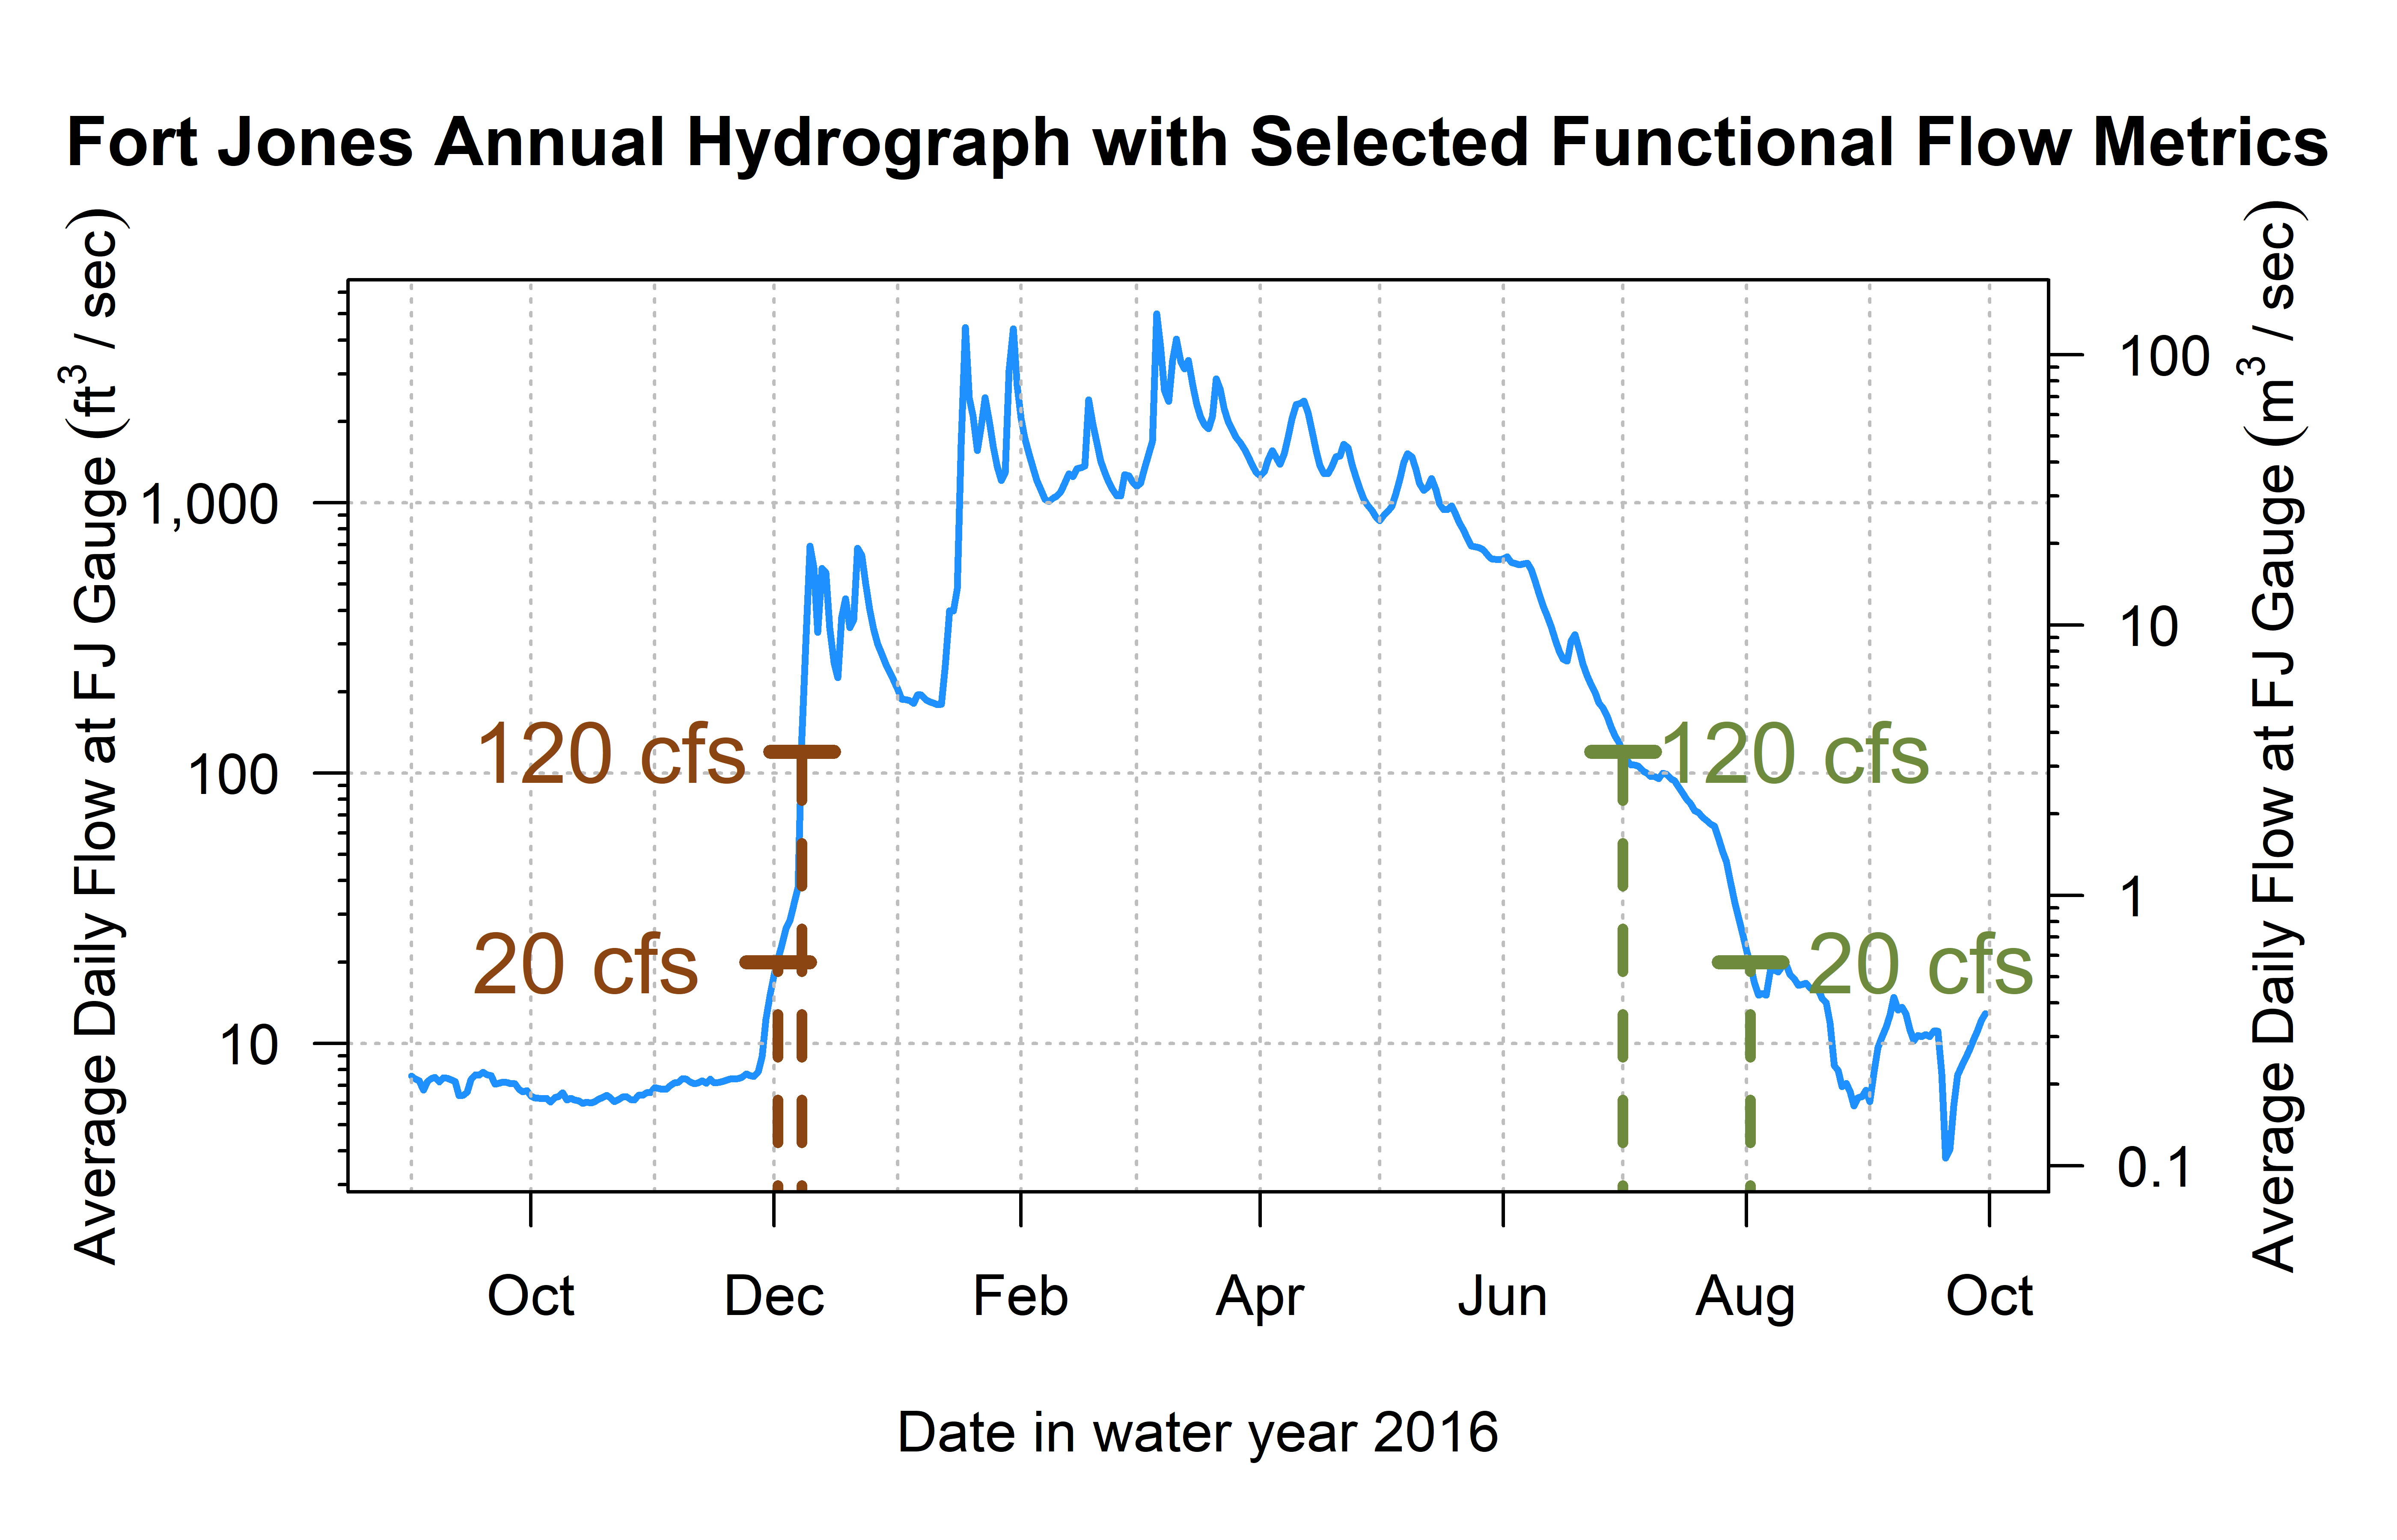

Figure 11: Reconnection and disconnection dates are highlighted for one water year. Two example thresholds, 20 and 120 cfs (0.57 and 3.4 cms, respectively) are highlighted, which correspond to distinct river connectivity (and salmon habitat access) conditions in the Scott River watershed as observed at the Fort Jones gauge (see Results for more detail on selection of flow thresholds).

# 13 Screening Predictors for Collinearity

Table 7: Groups of collinear predictors (absolute value of R greater than 0.7), interpretation of their hydrologic significance, and the predictor selected from each group to reduce collinearity.

| Group of Collinear Predictors | Hydrologic Significance (Coho Life Stage) | Predictor Selected from Group |
| --- | --- | --- |
| wy1_Mean_Ann_Flow, s1_discon_20, s1_discon_40, s1_discon_120, f2_recon_20, f2_recon_40, w1_Wet_BFL_Mag_10, w1_Wet_BFL_Mag_50, s1_SP_Dur, s1_SP_Mag, wy1_WY_Cat, d2_DS_Tim, d2_DS_Mag_50, d2_DS_Mag_90, w1_num_days_gt_90_pctile | How wet was the wet season? (year 1, as eggs and fry) | w1_Wet_BFL_Mag_50 |
| wy2_Mean_Ann_Flow, s2_discon_120, w2_Wet_BFL_Mag_10, w2_Wet_BFL_Mag_50, s2_SP_Dur, s2_SP_Mag, wy2_WY_Cat, w2_num_days_gt_90_pctile | How wet was the wet season? (year 2, as rearing juv.) | w2_Wet_BFL_Mag_50 |
| d1_DS_Tim, f1_recon_20, f1_recon_40, d1_DS_Dur_WS, d1_DS_Mag_50 | How dry was the dry season? (pre-spawning | d1_DS_Mag_50 |
| w2_Wet_Tim, d2_DS_Dur_WS, f2_FA_Tim, w2_Wet_BFL_Dur | Dry to wet season transition timing (as rearing juv.) | w2_Wet_Tim |
| w1_Wet_BFL_Dur, w1_Wet_Tim, s1_SP_Tim | How long was the wet season (as eggs and fry) | w1_Wet_BFL_Dur |
| f1_FA_Mag, f1_FA_Dif_num | Fall pulse magnitude (parents' spawning) | f1_FA_Dif_num |
| f2_FA_Mag, f2_FA_Dif_num | Fall pulse magnitude (rearing juv.) | f2_FA_Dif_num |

## 13.1 Groups 1 and 2

These metrics describe the magnitude and timing of wet-season flows (years 1 and 2), effectively characterized by the question, how wet was the wet season?. We selected w1_Wet_BFL_Mag_50 and w2_Wet_BFL_Mag_50 as the most conceptually central metric to represent the amount of water passing through the watershed during two wet seasons: w1, the first wet season, experienced by a cohort as eggs and newly-hatched alevin and fry, and w2, experienced by the cohort as overwintering parr.

## 13.2 Group 3

These metrics describe the magnitude and timing of dry-season flows before the cohort’s spawning. We selected d1_DS_Mag_50 as the most conceptually central metric to represent the amount of water passing through the watershed during the dry season before a cohort’s parents’ spawning.

## 13.3 Groups 4 and 5

These metrics quantify the timing of the wet season onset and duration (year 2). We selected w2_Wet_Tim, the timing of the onset of the second wet season, and w2_Wet_BFL_Dur, the duration of wet season baseflow, to characterize the timing of the wet season experienced by a cohort of coho as overwintering juveniles.

## 13.4 Groups 6 and 7:

These metrics quantify the magnitude of the fall pulse flow (years 1 and 2). Although FA_num_diff had a higher sample size, we selected f1_FA_Mag and f2_FA_Mag to better reflect the years in which an identifiable fall pulse occurred before the onset of the wet season.

# 14 Ecological Data Features

Plot spawners vs juveniles and spawners vs redds (color coded by year?)

Plot ACF for each eco record

Table 8: Description and source information for ecological observations of the two salmonid species of concern.

| Obs. ID | Abbrev. | Description | Monitoring Details | Source(s) | Predictor Seasons |
| --- | --- | --- | --- | --- | --- |
| A | coho_spawner_abundance | Num. coho spawners (escapement) | Scott River Fish Counting Facility | Knechtle and Guidice 2023, CDFW | d1, f1, w1 |
| B | coho_redds_in_brood | Num. obs. coho redds | Spawning ground surveys | Sources in Section 3.2 | d1, f1, w1, s1 |
| C | coho_smolt_abun_est | Est. num. coho smolt | Rotary Screw Trap | Romero and Robinson, 2023 | d1, f1, w1, s1, d2, f2, w2, s2 |
| D | chinook_spawner_abundance | Num. Chinook spawners (escapement) | Scott River Fish Counting Facility | Knechtle and Guidice 2023, CDFW | d1, f1, w1 |
| E | chinook_spawner_old_method | Num. Chinook spawners (escapement) | Temporary fish marking weir, 1985-1991; capture-recapture method, 1992-2012; video fish counting facility post-2012 | Knechtle and Chesney 2012 | d1, f1, w1 |
| F | chinook_juvenile_abundance | Num. Chinook juveniles | Rotary Screw Trap | Romero and Robinson, 2023 | d1, f1, w1, s1 |
| -- | coho_smolt_per_fem | Coho smolt per fem. spawner | Ratio (C/A) for relevant cohort | Knechtle and Guidice 2023, CDFW | d1, f1, w1, s1, d2, f2, w2, s2 |
| -- | chinook_juv_per_adult | Chinook juv. per adult | Ratio (F/D) for relevant cohort | Knechtle and Guidice 2023, CDFW | d1, f1, w1, s1 |

## png   
## 2

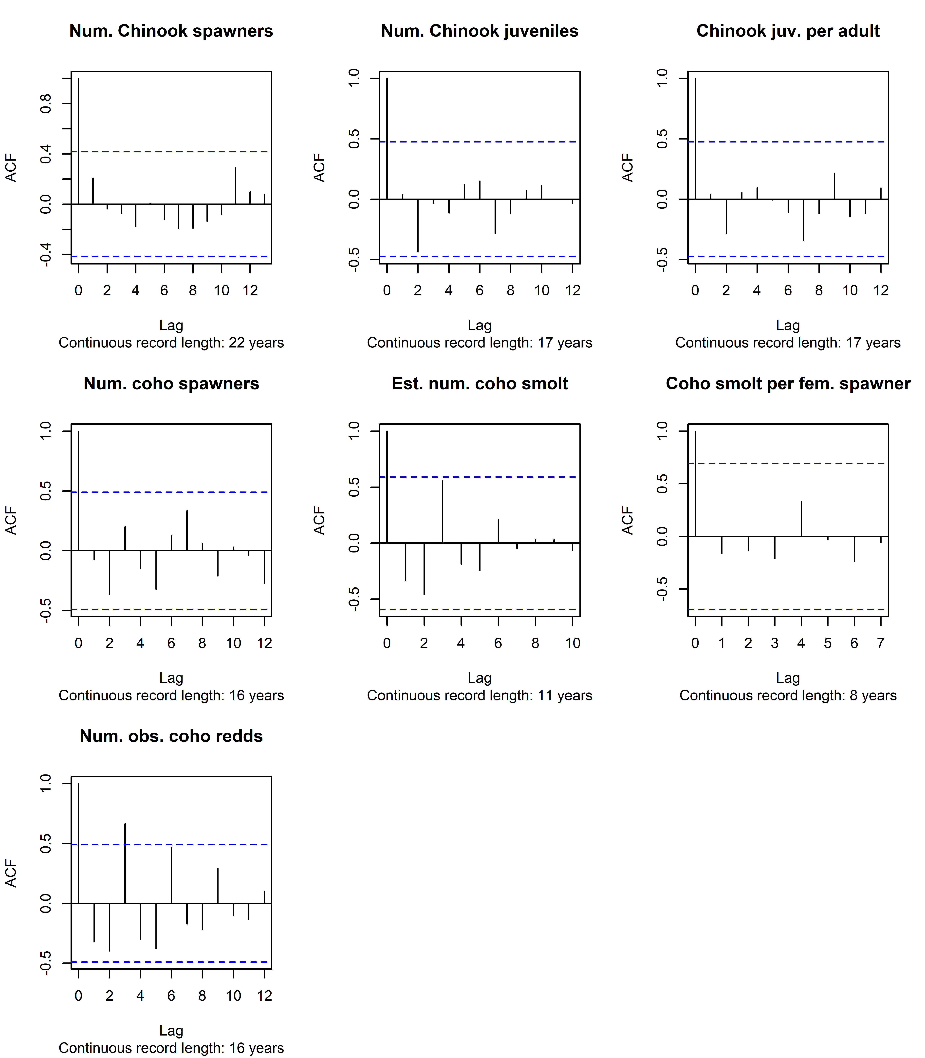

Figure 12: Autocorrelation function estimates for all available ecological outcome records.

# 15 Statistical Method Details

## 15.1 LASSO regression

LASSO (Least Absolute Shrinkage and Selection Operator) regression minimizes the following quantity:

$$\sum_{i=1}^{n}{{\left(y_{i}-β_{0}-\sum_{j=1}^{p}{β_{j}x_{ij}}\right)}^{2}}+λ\sum_{j=1}^{p}{\left|β_{j}\right|}$$

Where:

* $n$ is the number of ecological observations;
* $i$ enumerates the brood years;
* $p$ is the number of predictors;
* $j$ enumerates the hydrologic predictors;
* $x_{ij}$ is the observed value of hydrologic predictor $j$ for brood year $i$ (independent variable);
* $y_{i}$ is the observed value of ecological response in the salmon cohort with brood year $i$ (dependent variable);
* $β_{0}$ is the intercept value for the resulting linear model;
* $β_{j}$ is the coefficient value for hydrologic predictor $j$ in the resulting linear model; and
* $λ$ is a tuning parameter, referred to as a shrinkage penalty.

In this formulation, sufficiently large values of lambda generally shrink the values of all coefficients to 0 (the infinite-lambda case). The infinite-lambda case produces a model consisting solely of the $β_{0}$ intercept term, which takes on a value that is the average of all the observed $y$ values. Conversely, sufficiently small values of $λ$ will produce linear models incorporating information from many predictors. The selection of the appropriate $λ$ value is a critical step in the regression procedure, and is best done using cross-validation within the training dataset (James et al. 2013). In this analysis a range of $λ$ values was explored for each species.

## 15.2 LASSO results, juvenile abundance on hydro. and spawners

## Warning: Option grouped=FALSE enforced in cv.glmnet, since < 3 observations per  
## fold  
## Warning: Option grouped=FALSE enforced in cv.glmnet, since < 3 observations per  
## fold

## png   
## 2

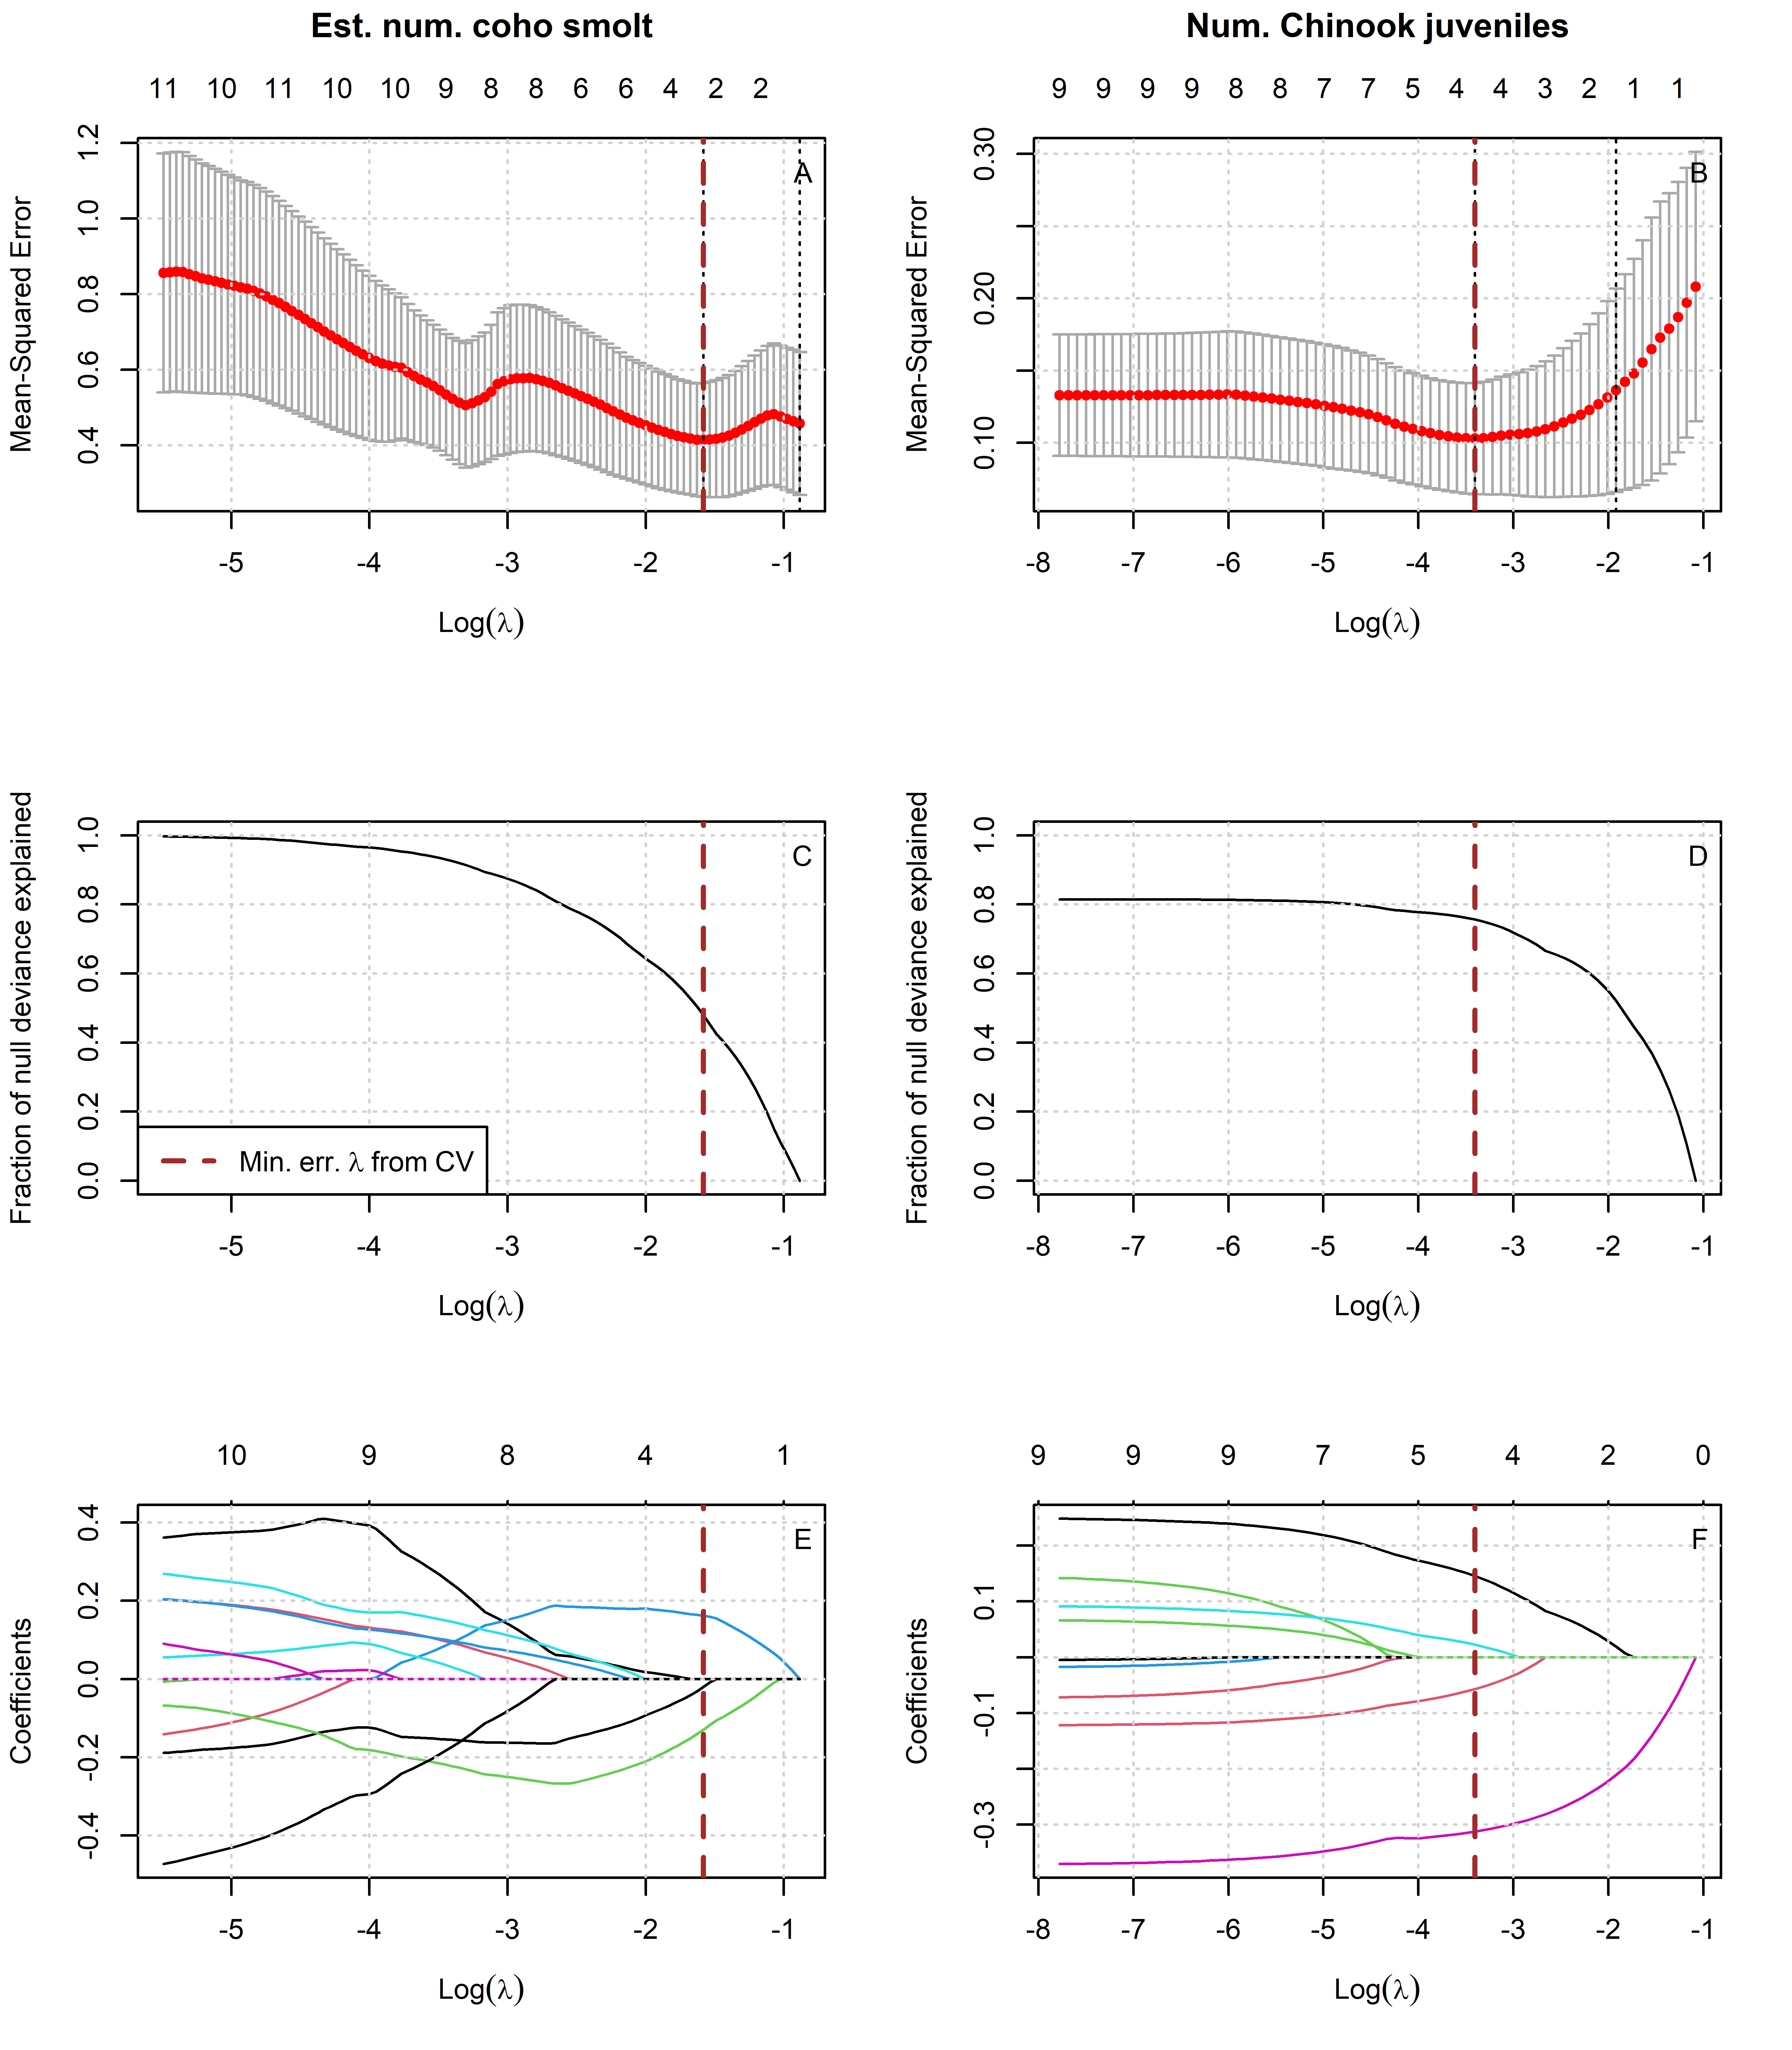

Figure 13: Results of lasso regression to predict log-transformed coho and Chinook outcomes with Z-scored hydrologic metrics. Models with more coefficients explain a greater fraction of deviance in the dataset (middle panel), but also produce higher test errors (top panel), indicating some overfitting at lower lambda values. Higher values of lambda tend to shrink the absolute values of regression coefficients toward 0 (bottom panel).

Table 9: Values for the intercept and coefficient terms in the Hydrologic Benefit function for estimated coho_smolt_abun_est, including a description of which phenomena are associated with higher ecological outcome values.

| Predictor | Value | Greater Hydrologic Benefit value associated with |
| --- | --- | --- |
|  | 3.872 | (Intercept) |
| f1_FA_Dif_num | 0.162 | Larger fall flow increase (during parents' spawning) |
| f2_FA_Dif_num | -0.130 | Smaller fall flow increase (as juvenile fish) |
| s1_SP_ROC | -0.020 | Slower rate of change, spring recession (as recent hatchlings) |

Table 10: Values for the intercept and coefficient terms in the Hydrologic Benefit function for estimatedchinook_juvenile_abundance, including a description of which hydrologic phenomena are associated with higher ecological outcome values.

| Predictor | Value | Greater Hydrologic Benefit value associated with |
| --- | --- | --- |
|  | 5.443 | (Intercept) |
| w1_Wet_BFL_Mag_50 | -0.312 | Lower wet season baseflows (as eggs and hatchlings) |
| chinook_spawners_zscored | 0.146 | Abundance of spawners (parents of designated cohort) |
| s1_SP_ROC_Max | -0.057 | Slower max. rate of change, spring recession (as outmigrating smolt) |
| w1_Wet_BFL_Dur | 0.023 | Longer wet season baseflow duration (as eggs and hatchlings) |

## 15.3 MARSS Models

### 15.3.1 MARSS models of juveniles per spawner, single hydrologic covariate

Multi-variate autoregressive state-space (MARSS) models are often used to model time series data (in which )

Table 11: Each row corresponds to a MARSS model predicting the time series of coho spf observations using itself (up to time t) and one hydrologic metric covariate. Coefficient sign and value indicate the direction and strength of the influence of the hydrologic metric; i.e., a negative coefficient for hydrologic metric f1_recon_120 indicates that an earlier first fall river reconnection (120 cfs) is associated with a greater coho spf value. Models are listed in order from best (lowest AICc value) to worst. Values marked with -- indicate that gaps in the time series for the hydrologic metric prevented the calculation of a model using that covariate.

| Covariate | Coefficient | AICc |
| --- | --- | --- |
| f1_recon_120 | -0.403 | 21.24 |
| f1_FA_Dif_num | 0.306 | 23.13 |
| w1_Wet_BFL_Mag_50 | 0.136 | 26.46 |
| d1_DS_Mag_90 | 0.102 | 27.05 |
| s2_SP_ROC_Max | -0.093 | 27.34 |
| f2_recon_120 | -0.173 | 27.5 |
| s2_SP_ROC | 0.085 | 27.55 |
| d1_DS_Mag_50 | -0.109 | 27.74 |
| w2_Wet_BFL_Mag_50 | 0.085 | 27.93 |
| s1_SP_ROC_Max | 0.046 | 28.25 |
| s2_SP_Tim | 0.029 | 28.26 |
| w2_Wet_Tim | -0.023 | 28.47 |
| f2_FA_Dif_num | 0.036 | 28.5 |
| s1_SP_ROC | 0.007 | 28.55 |
| w1_Wet_BFL_Dur | 0.003 | 28.55 |
| f1_FA_Dur | -- | -- |
| f1_FA_Tim | -- | -- |
| f2_FA_Dur | -- | -- |

Table 12: Each row corresponds to a MARSS model predicting the time series of Chinook jpa observations using itself (up to time t) and one hydrologic metric covariate. Coefficient sign and value indicate the direction and strength of the influence of the hydrologic metric; i.e., a negative coefficient for hydrologic metric f1_recon_120 indicates that an earlier first fall river reconnection (120 cfs) is associated with a greater Chinook jpa value. Models are listed in order from best (lowest AICc value) to worst. Values marked with -- indicate that gaps in the time series for the hydrologic metric prevented the calculation of a model using that covariate.

| Covariate | Coefficient | AICc |
| --- | --- | --- |
| d1_DS_Mag_90 | 0.069 | 28.91 |
| s1_SP_ROC_Max | -0.057 | 29.17 |
| f1_recon_120 | -0.039 | 29.61 |
| w1_Wet_BFL_Dur | -0.019 | 29.7 |
| d1_DS_Mag_50 | -0.039 | 29.72 |
| w1_Wet_BFL_Mag_50 | 0.031 | 29.74 |
| f1_FA_Dif_num | -0.013 | 29.88 |
| s1_SP_ROC | 0.002 | 29.89 |
| f1_FA_Dur | -- | -- |
| f1_FA_Tim | -- | -- |

## png   
## 2

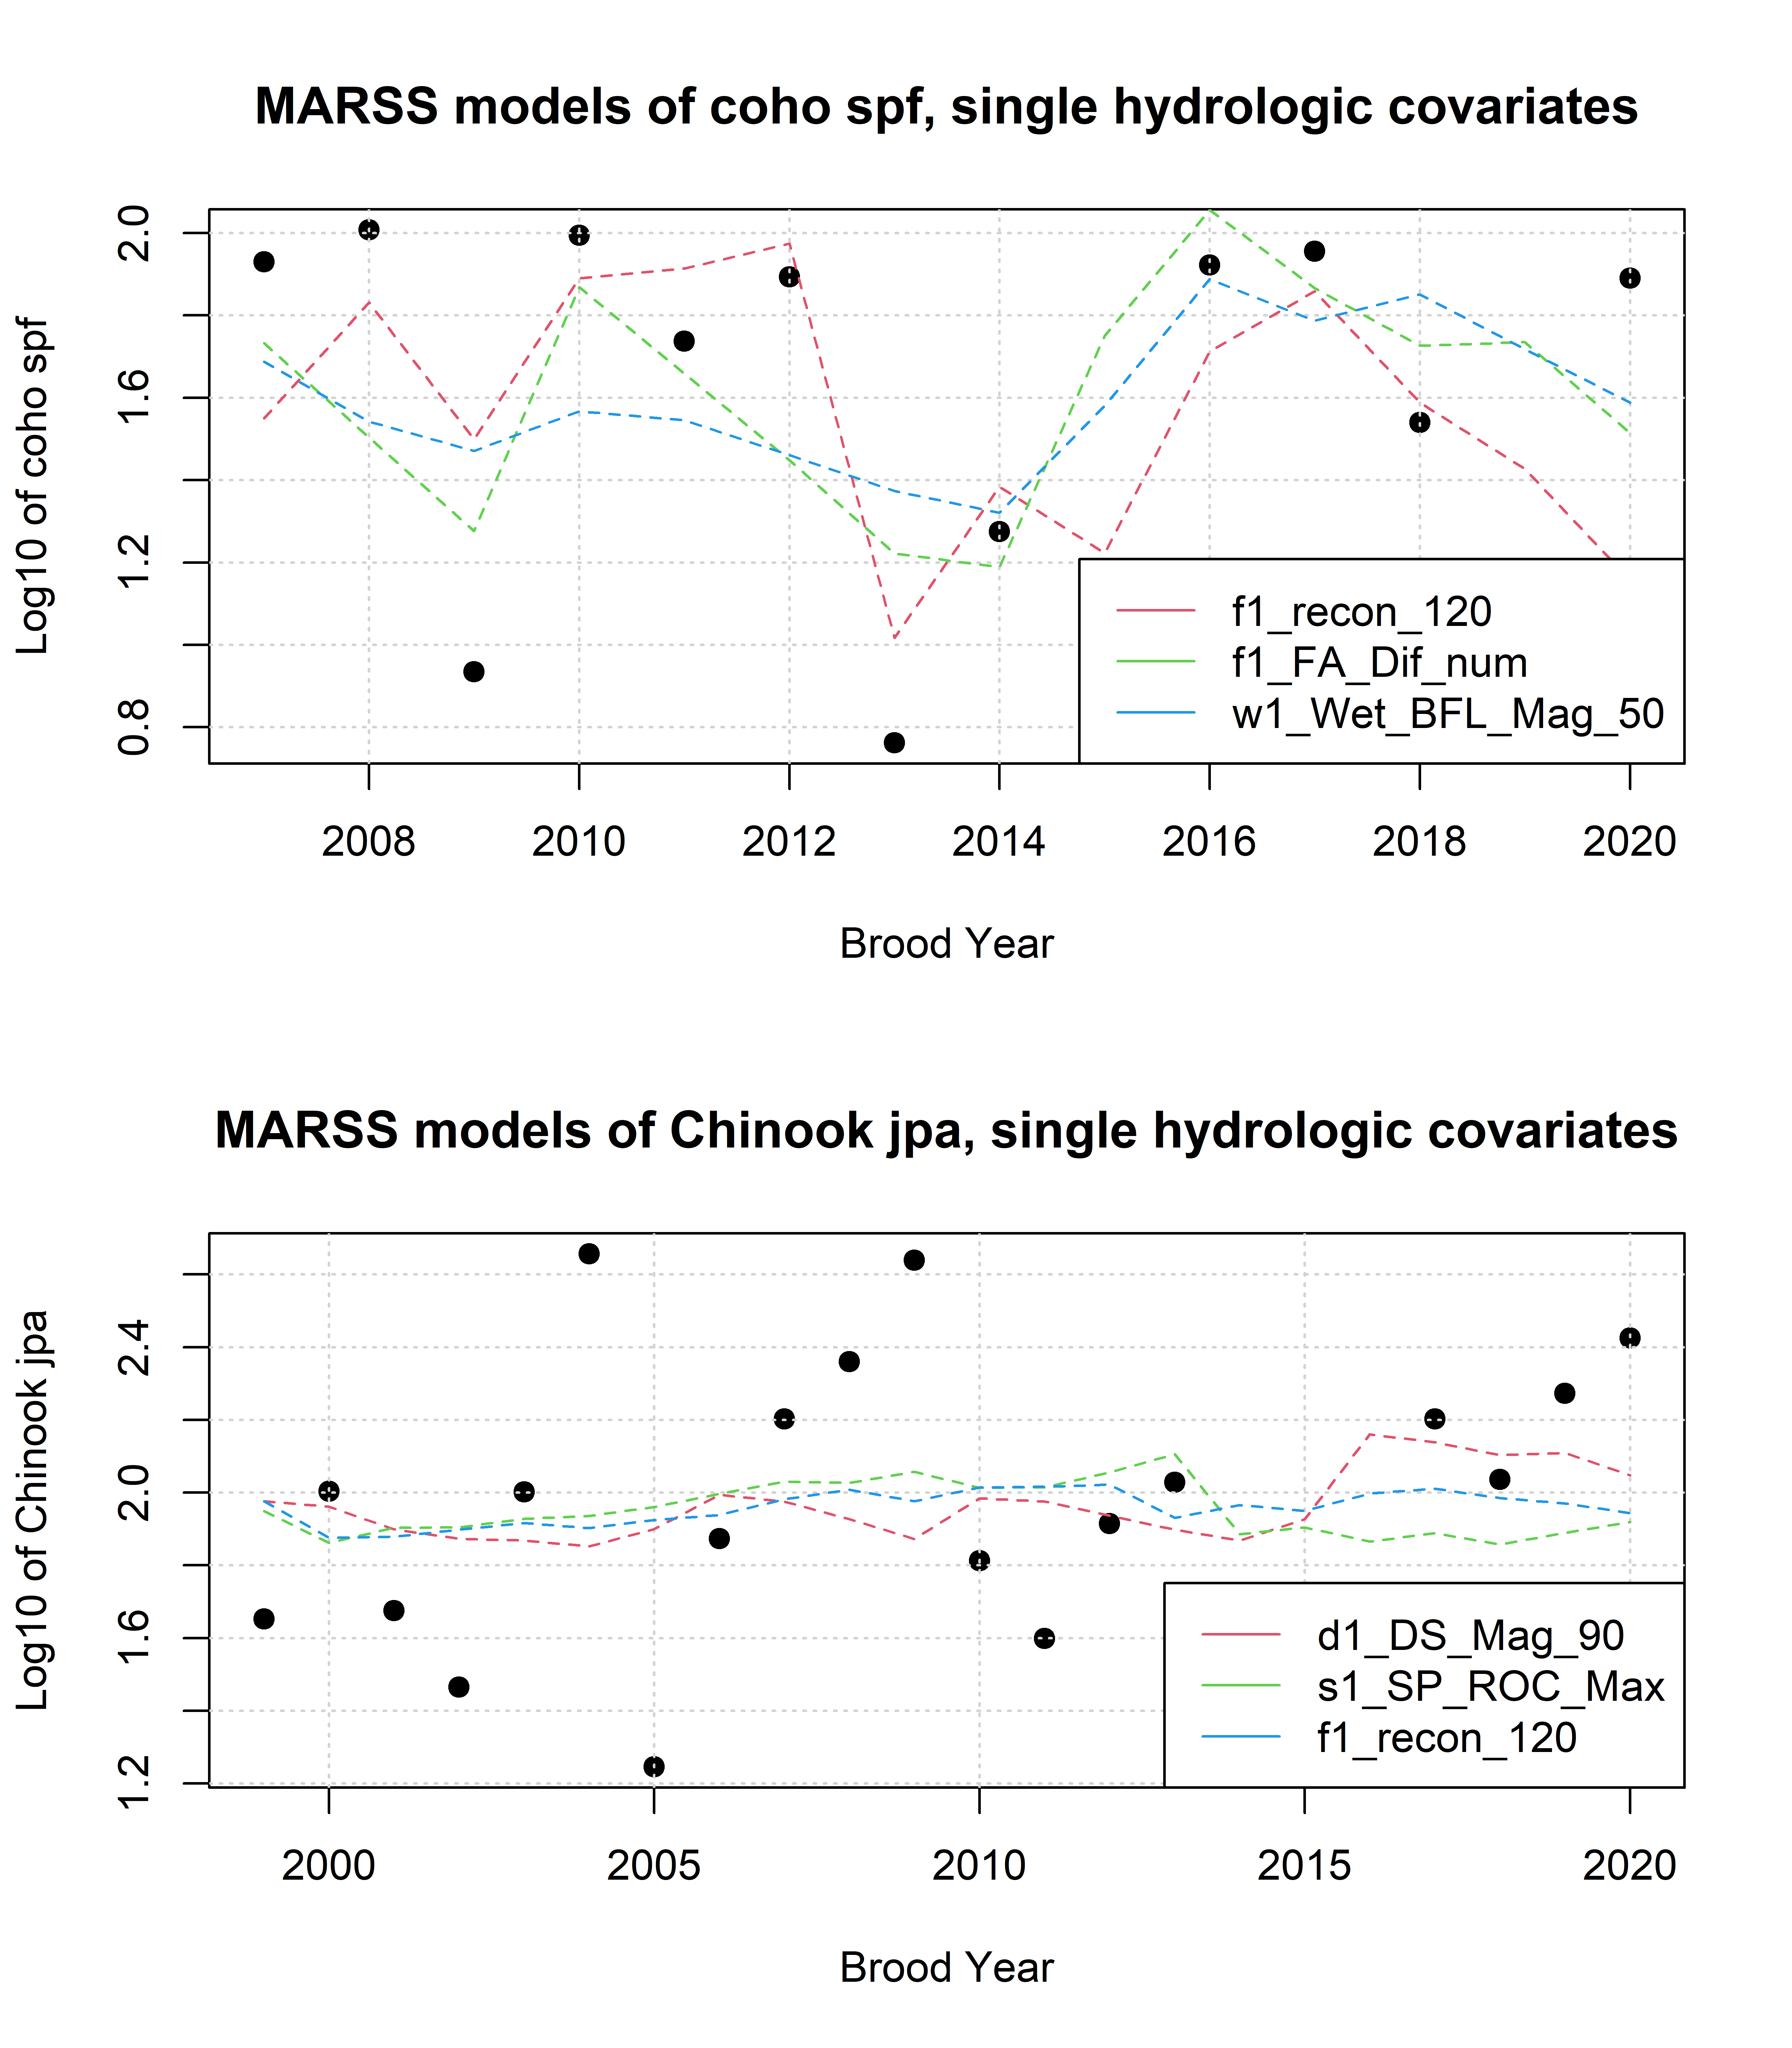

Figure 14: Results of the three best single-hydrologic-covariate MARSS models to predict log-transformed Chinook and coho outcomes with Z-scored hydrologic metrics.

### 15.3.2 MARSS models, two covariates (spawner abundance and one hydrologic)

As another technique, we could attempt to model observed juvenile abundance using each hydrologic metric paired with the observed spawner abundance among the parents of a given cohort.

| Hydrologic Covariate | AICc | Hydro Coef. | Spawner Coef. | HtoSratio |
| --- | --- | --- | --- | --- |
| f1_FA_Dif_num | 32.11 | 0.550 | 0.374 | 1.5 |
| f1_recon_120 | 37.67 | -0.605 | 0.452 | -1.3 |
| d1_DS_Mag_90 | 38.16 | 0.229 | 0.338 | 0.7 |
| w1_Wet_BFL_Mag_50 | 38.27 | 0.245 | 0.301 | 0.8 |
| f2_recon_120 | 40.62 | -0.237 | 0.161 | -1.5 |
| w2_Wet_BFL_Mag_50 | 41.18 | 0.110 | 0.201 | 0.5 |
| s1_SP_ROC | 41.32 | -0.065 | 0.160 | -0.4 |
| s1_SP_ROC_Max | 41.50 | 0.052 | 0.186 | 0.3 |
| w2_Wet_Tim | 41.50 | 0.049 | 0.176 | 0.3 |
| d1_DS_Mag_50 | 41.61 | 0.045 | 0.164 | 0.3 |
| f2_FA_Dif_num | 41.65 | -0.040 | 0.160 | -0.2 |
| s2_SP_ROC | 41.66 | 0.017 | 0.169 | 0.1 |
| s2_SP_Tim | 41.67 | -0.010 | 0.159 | -0.1 |
| w1_Wet_BFL_Dur | 41.67 | 0.010 | 0.167 | 0.1 |
| s2_SP_ROC_Max | 41.68 | -0.004 | 0.167 | 0.0 |
| f1_FA_Dur |  |  |  |  |
| f1_FA_Tim |  |  |  |  |
| f2_FA_Dur |  |  |  |  |
| Hydrologic Covariate | AICc | Hydro Coef. | Spawner Coef. | HtoS_ratio |
| s1_SP_ROC_Max | 36.03 | -0.116 | 0.0573 | -2.0 |
| w1_Wet_BFL_Mag_50 | 36.06 | -0.132 | 0.0209 | -6.3 |
| f1_recon_120 | 37.77 | -0.062 | 0.0361 | -1.7 |
| d1_DS_Mag_50 | 37.81 | 0.081 | 0.0183 | 4.4 |
| w1_Wet_BFL_Dur | 37.84 | 0.035 | 0.0426 | 0.8 |
| f1_FA_Dif_num | 38.18 | -0.046 | 0.0318 | -1.4 |
| s1_SP_ROC | 38.19 | 0.021 | 0.0528 | 0.4 |
| d1_DS_Mag_90 | 38.35 | 0.004 | 0.0378 | 0.1 |
| f2_recon_120 |  |  |  |  |
| f1_FA_Dur |  |  |  |  |
| f1_FA_Tim |  |  |  |  |
| f2_FA_Dur |  |  |  |  |
| f2_FA_Dif_num |  |  |  |  |
| w2_Wet_BFL_Mag_50 |  |  |  |  |
| w2_Wet_Tim |  |  |  |  |
| s2_SP_ROC |  |  |  |  |
| s2_SP_ROC_Max |  |  |  |  |
| s2_SP_Tim |  |  |  |  |

## png   
## 2

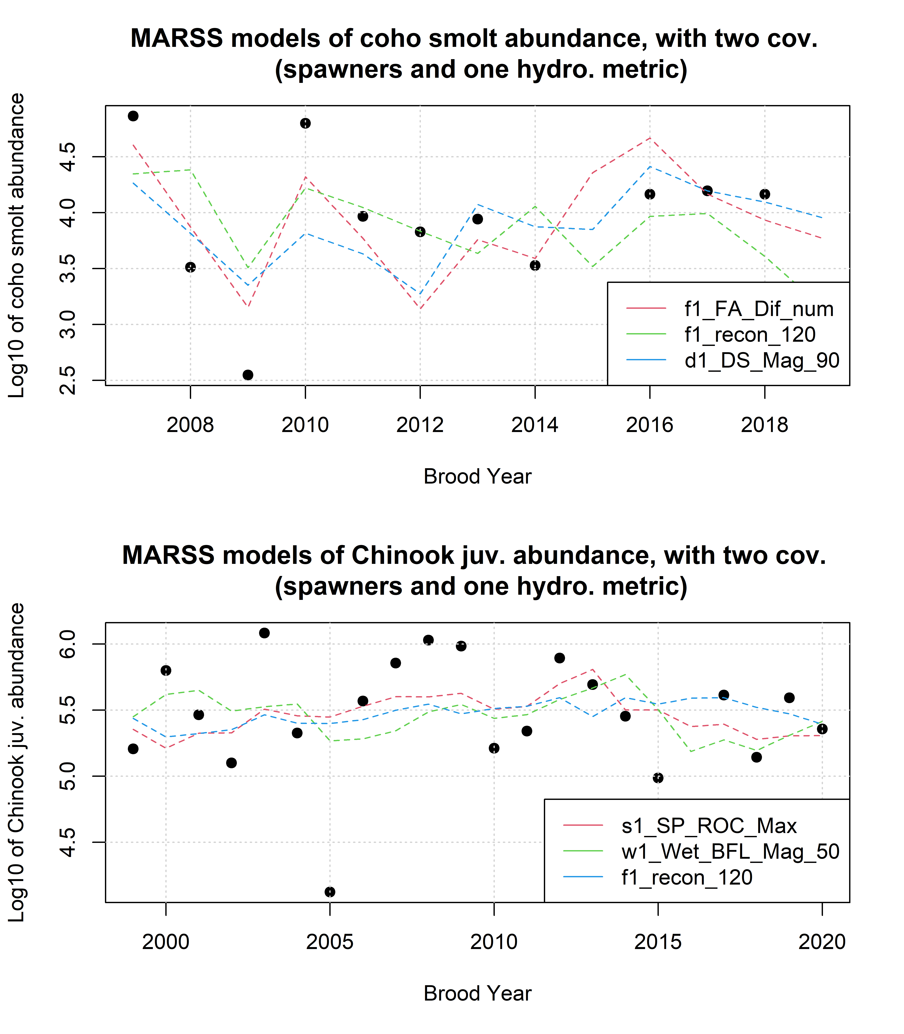

Figure 15: Results of MARSS to predict log-transformed Chinook outcomes with Z-scored hydrologic metrics plus spawner data.

# 16 References